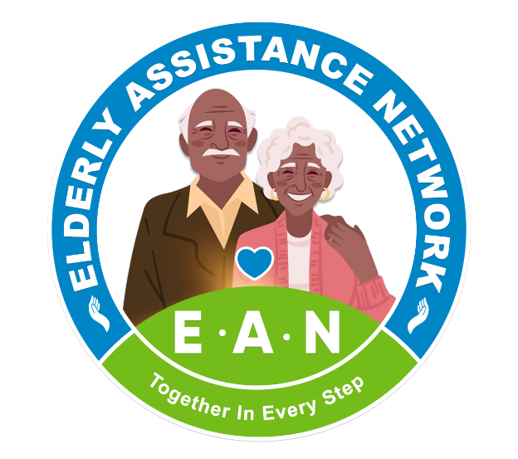

EAN Microproject Brief

Protect Older People from Abuse in Rural Malawi

Elderly Assistance Network (EAN)

About EAN
The Elderly Assistance Network (EAN) is a community-based organization working to improve the wellbeing, dignity, protection, and inclusion of older persons in Malawi. EAN supports vulnerable older people through community outreach, health initiatives, advocacy, awareness campaigns, and social support activities.
EAN works closely with older persons, families, community leaders, healthcare workers, and volunteers to address the challenges affecting older people in rural communities. The organization is committed to promoting respect, protection, and equal participation of older persons in society.

Project Title

Protect Older People from Abuse in Rural Malawi

Project Summary
Older people in many rural communities in Malawi face abuse, neglect, discrimination, social exclusion, and harmful witchcraft accusations. Many older persons live alone, lack support systems, and are vulnerable to emotional, physical, and financial abuse.
This microproject aims to protect vulnerable older people through community awareness activities, village dialogues, home visits, advocacy, and community engagement. The project will work with families, youth, local leaders, and volunteers to promote respect for older persons and reduce harmful practices and violence.
Through this initiative, EAN seeks to create safer and more supportive communities where older people can live with dignity and protection.

The Problem
Abuse against older people remains a serious but often overlooked issue in rural Malawi. Older persons are frequently accused of practicing witchcraft, especially older women, leading to violence, isolation, discrimination, and in some cases death.
Many older people are also neglected by family members, excluded from community participation, and denied proper care and support. Poverty, limited awareness, and harmful cultural beliefs contribute to the continued abuse and mistreatment of older persons.
Despite these challenges, many abuse cases go unreported because communities lack awareness, protection systems, and support services for older persons.

Project Goal
To reduce abuse, neglect, discrimination, and harmful witchcraft-related violence against older people in rural Malawi through community awareness, advocacy, and protection activities.

Project Objectives
- Raise community awareness on the rights and protection of older persons.
- Reduce harmful beliefs and witchcraft accusations against older people.
- Promote respect, dignity, and inclusion of older persons in families and communities.
- Strengthen community responsibility in identifying and reporting abuse cases.
- Support vulnerable older persons through outreach and referral activities.

Planned Activities

Community Awareness Meetings
EAN will organize community sensitization sessions with families, youth, and community members to discuss elder abuse, neglect, discrimination, and witchcraft accusations.

Village Dialogues
The organization will conduct open discussions with older persons and local leaders to understand community challenges and encourage community-led solutions.

Home Visits
EAN volunteers and team members will conduct home visits to vulnerable older persons to assess needs, provide psychosocial support, and identify abuse or neglect cases.

Local Leader Engagement
Traditional leaders and community influencers will be engaged to promote protection of older persons and discourage harmful practices and violence.

Advocacy and Referral Support
The project will encourage reporting of abuse cases and help connect vulnerable older persons to available local support and referral services.

Expected Impact
This project will help increase awareness about elder abuse and strengthen community responsibility for protecting older persons.
The project is expected to:
- Reduce cases of abuse, neglect, and discrimination.
- Promote peaceful community responses to witchcraft accusations.
- Improve respect and inclusion of older persons.
- Increase reporting and identification of abuse cases.
- Strengthen support systems for vulnerable older persons.
The project is expected to directly and indirectly benefit approximately 300–500 older persons and community members in target rural communities.

Long-Term Impact
In the long term, this project will contribute to safer and more inclusive communities where older people are respected, protected, and valued.
By addressing harmful beliefs, strengthening community awareness, and encouraging local leadership involvement, the project aims to reduce violence and exclusion affecting older persons.
The initiative will also help build lasting community-based protection systems that continue supporting vulnerable older persons beyond the project period.

Simple Budget Overview
Activity Estimated Cost (USD)
Community awareness meetings | $300
Village dialogues | $250
Home visits and outreach | $250
Transport and logistics | $300
Awareness materials | $150
Volunteer support and coordination | $150
Administrative and communication costs | $100
Total | $1,500

Why Your Support Matters
Your support will help EAN protect vulnerable older people from abuse, neglect, and harmful discrimination in rural Malawi.
By supporting this project, donors will help strengthen community awareness, encourage peaceful and respectful treatment of older persons, and improve protection systems for vulnerable elders.
Every contribution helps older people live with greater dignity, safety, and inclusion.

Contact Information

Elderly Assistance Network (EAN)
Malawi
Email: info@eanmalawi.org
Website: http://eanmalawi.org/
LinkedIn: https://www.linkein/in/eldery-assistance-network-ean-016342323
Facebook: https:www.facebook.com/profile.php?id=61566579183583

Thank You
EAN appreciates the support of donors, partners, volunteers, and community members working together to protect and promote the dignity and wellbeing of older persons in Malawi.

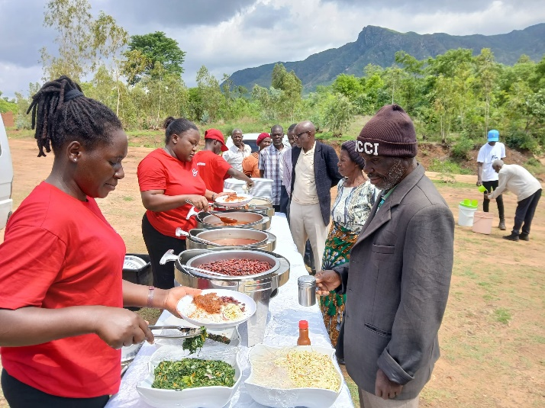
Older people receiving nutritious meals during EAN's community feeding program

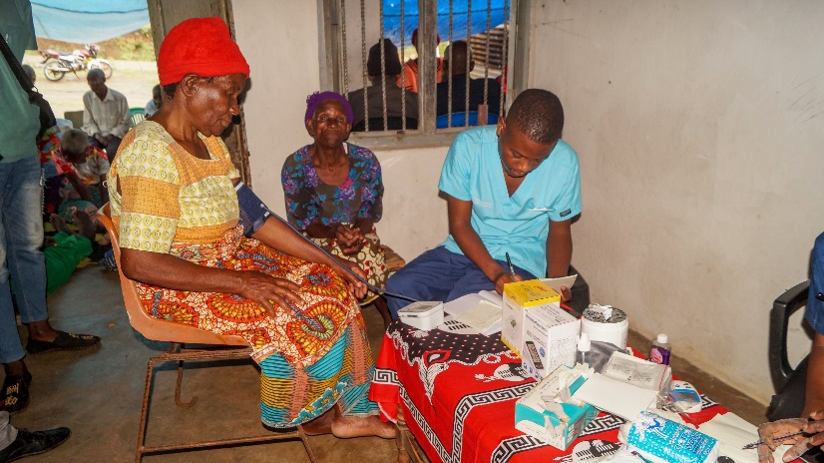
Figure 1EAN health personnel conducting monthly health outreach services for older people

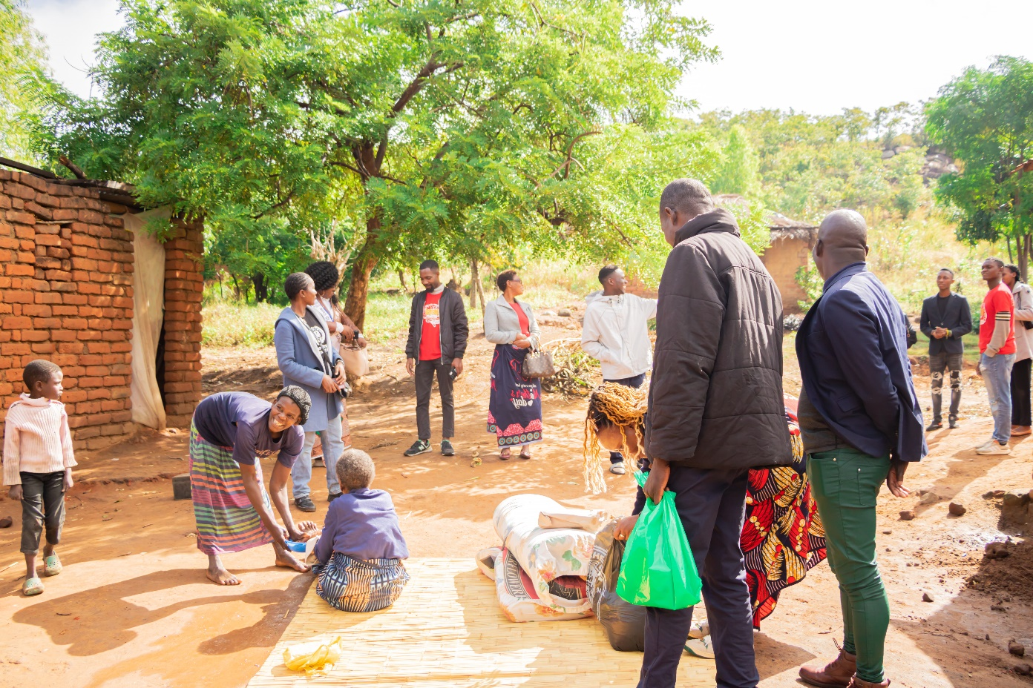
Home visits to elderly beneficiaries

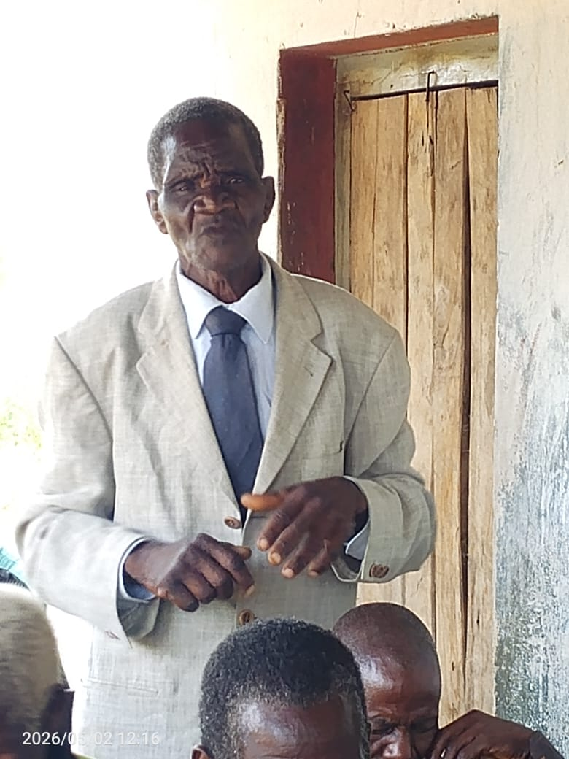
Group discussion on elder abuse, health, and well-being
