A Mother’s Prayer, A Child’s Courage: The Story of Gevara
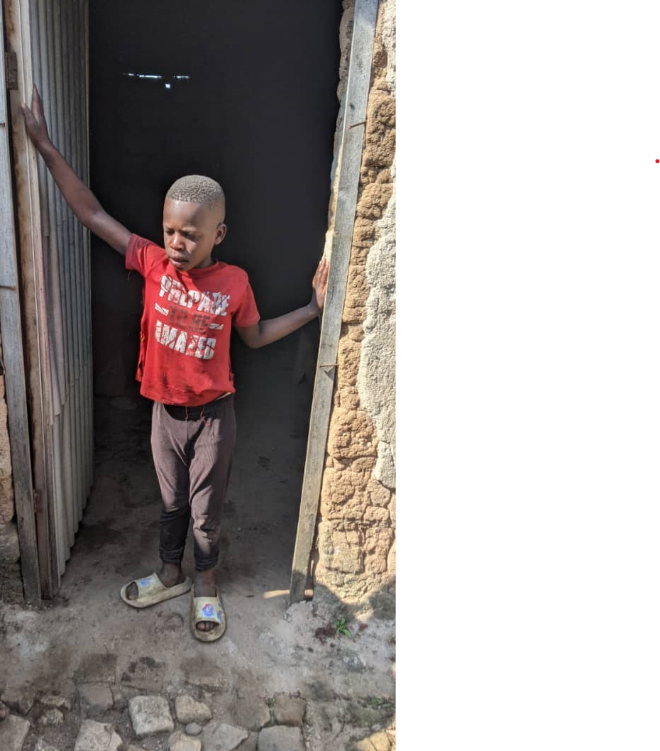
Gevara at his Home in Nyamagana B Village/Nyanza
In the quiet hills of Nyanza District lives Gevara, a 11-year-old boy whose life has been a story of both pain and incredible hope.
Gevara was born with a severe spinal condition. Immediately after his birth, doctors tried to correct it with medical braces, but after long months in the hospital, his condition remained unchanged. His mother, Elisabeth, left the hospital with her baby unhealed still unable to hold his head up, unable to sit, and completely dependent on her care.
Those first years were a constant struggle. By age of two, Gevara could not sit, crawl, or even hold his neck upright without support. His mother carried him everywhere, knowing that without her, he had no chance. Already poor, she had to give up working entirely to stay home with her son. When her husband abandoned the family, she was left completely alone.
Since then, survival has been a daily battle, moreover Elisabeth is homeless, moving from place to place, depending on the kindness of others for temporary shelter. To feed her children, she works as a casual laborer on other people’s farms, earning a meager wage that barely covers their daily needs. Neighbors, touched by her struggle, sometimes share food, but stability is still far out of reach.
Yet in the midst of despair, Elisabeth refused to give up. She turned her pain into prayer, asking God for strength. Then, when Gevara was five years old, a stranger came to her door, a preacher who did not know her or her child. She prayed with her and told her, “Your son will rise and walk.” It sounded impossible, but shortly after, Gevara began to do the unthinkable: he sat for the first time, and then slowly, he started to stand. By age seven, he was walking.
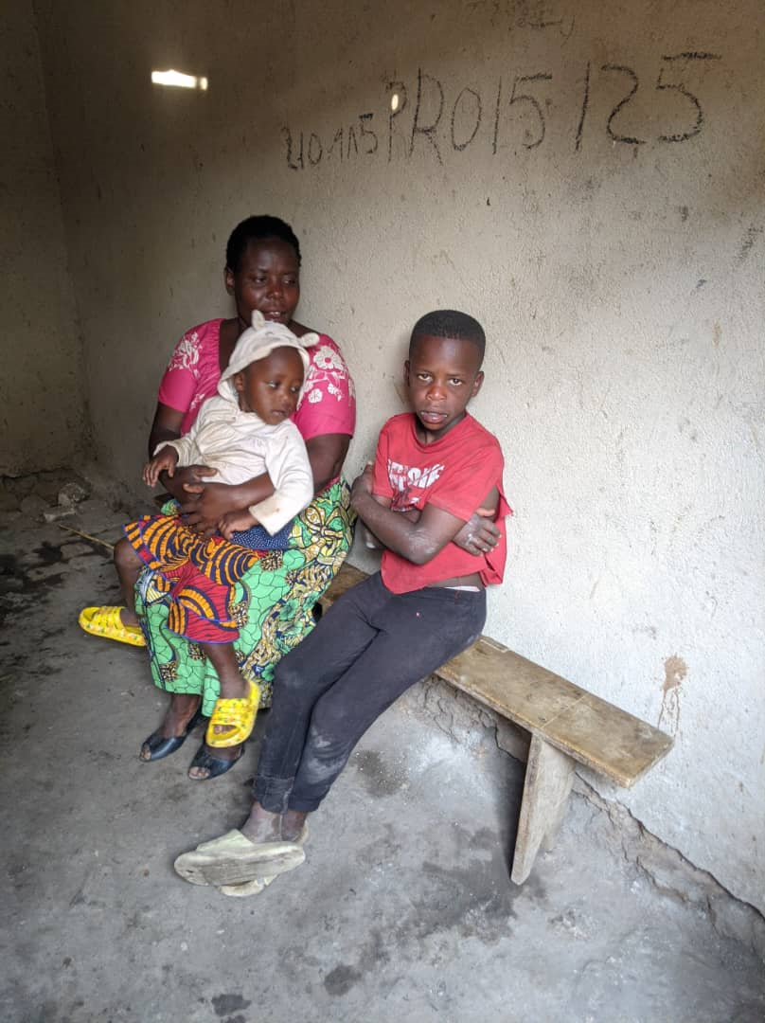
Gevara with his mother and sibling
For Elisabeth, it was a miracle. Her son, once thought destined to remain bedridden, was now moving on his own. Hope was reborn in her heart.
But Gevara’s challenges did not end there. His neck remained weak, he struggled to speak, and his little hands could not grasp objects. At school and in play, he lagged behind other children. Still, his mother refused to hide him away. She enrolled him in a childcare program where he could learn, play, and gain confidence.
Today, at 11 years old, Gevara is walking with strength. He can speak a few words, and his laughter fills his home. He attends the Dufatanye Organization’s Saturday Children’s Program, where he learns handcrafts, values, bible teachings and discovers his talents alongside other children. For the first time, he is not just a boy with a disability he is a boy with dreams.
And yet, his journey is far from over. Gevara still urgently needs specialized medical care to strengthen his speech, hands, and coordination. His mother, though incredibly strong, cannot do this alone. She has carried him as far as she can, while struggling with homelessness and uncertain work.
With your support, Gevara’s story can continue to be one of transformation. Your generosity can provide him with expert doctors, therapy, safe shelter, and opportunities that will allow him not just to survive, but to thrive.
When you help Gevara, you are not only changing his life, you are giving his mother’s prayer a lasting answer, and proving that no child is ever too broken to dream again.
ESTIMATED BUDGET NEEDED

Category / Item | Quantity | Unit Cost (USD) | Total (USD) | Description / Justification
A. Medical & Therapy Support
Doctor consultation (specialist check-up) | 12 | 45 | 540 | Monthly follow-up and evaluation.
Physiotherapy sessions | 12 | 45 | 540 | Monthly physiotherapy for mobility and strength.
Speech therapy sessions | 12 | 45 | 540 | Monthly sessions to improve communication.
Transport (mother + child round trip to Kigali) | 12 | 15 | 180 | Monthly transport for therapy visits.
Subtotal A |  |  | 1,800
B. Shelter & Family Support
Rent (safe housing) | 12 | 45 | 540 | Monthly rent for stability.
Basic household items (bedding, utensils, mats) | 10 | 40 | 400 | Purchased once for basic home setup.
Subtotal B |  |  | 940
C. Child Development & Education
School supplies and uniform | 1 | 45 | 45 | For one academic year.
Subtotal C |  |  | 45
D. Family Livelihood & Food Support
Monthly food basket (beans, flour, oil, soap) | 10 | 40 | 400 | Basic nutrition for the family.
Subtotal D |  |  | 400
Grand Total |  |  | 3,185

