Project proposal on Educational materials support for 700 children of low-income families

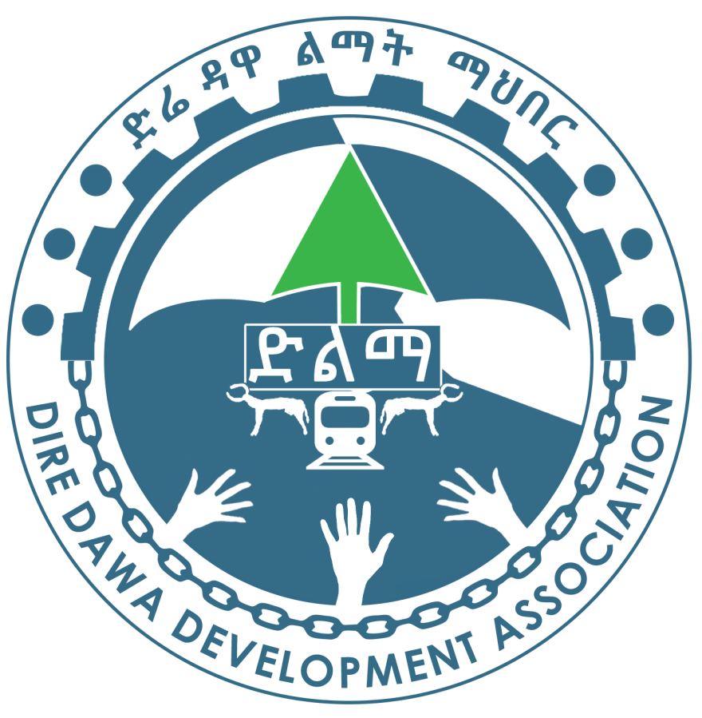

Submitted to : Global Giving

January/2025
Dire Dawa

- Summary
1,1 General Objective:
The program has the overall goal of contributing towards the country’s development and poverty reduction efforts through educational support for highly vulnerable children.
This project will provide educational stuffs (bags, notebooks, pen, pencil, stationary, etc.) to more than 700 underprivileged poor students in Dire Dawa rural areas so that they may be able to develop their educational standard. This project will help the marginalized children to get better opportunities to be educated and to contribute in the development of society.
1.2 Project and Budget
Title of the Project | Educational materials support for children of low-income families
Implementer | Dire Dawa Development Association
Implementation Period | August to September 2025
Location | Dire Dawa
Total AMOUNT IN DOLLAR | US $ 9996.75
from Fund agency

  - General Information
Details of the Branch | Name: Dire Dawa Development Association
Details of the Branch | Address: Ethiopia-Dire Dawa
Details of the Branch | Telephone 251-025-2110910
Details of the Branch | E-mail DDDA@ethionet.org  Website www.dda.org.et
Contact person of the Association | Name Ketema Tesema Gebre Mariam
Contact person of the Association | Position Manager of the Association
Contact person of the Association | Telephone 251- 0915734922
Contact person of the Association | E-mail ketesema@yahoo.com
Beneficiaries | Direct: 700 needy children in rural areas of the country
Beneficiaries | Indirect: 3500 family members

- Introduction
Established in 2007 Dire Dawa Development Association has been carrying out various development activities in Dire Dawa. It has been intervening in food security, education, health and water, capacity building and income generation.
These major areas of intervention were aimed to contribute to improvement in the standard of living of peoples in the area. In these years, the association has benefited many peoples in the zone. Nowadays the association is planned to prepare 5 years strategic plan. From this Dire Dawa Development Association plan will produce a 5 years Integrated Development Program that ranges from 2023 to 2027 and has already established technical committee,

The vision
To see the people of Dire Dawa Administration with enhanced attitude of preparedness and self-reliance, and solving its development challenges by its own capacity through united and concerted efforts in the year 2033.

The mission
DDDA is mobilizing and coordinating the capacity of the people, members, and its supporters to foster the development endeavor and benefit of the people of Dire Dawa Administration in the areas of Health, Education, Employment creation, and others in a sustained community involvement.

DDDA `s core Values
- Excellent leadership which inspires employees and members to act in support of the organization’s strategic objectives
- All employees, management and Board members are focused on making a real sustainable difference for all Dire dawa people. All activities are focused on delivering result oriented quality services on a timely basis making best use of available but limited resources.
- DDDA will operate in a fully transparent environment with all employees understanding their accountabilities and responsibilities.
- DDDA believes in upholding the highest degree of honesty and integrity in all its’ relationships.
- DDDA will abide by the rule of law in all matters.
- DDDA understands the value of involving all interested parties (employees, beneficiaries, members, community members and partners) in all its’ activities. DDDA works in partnership with other charities, networks and government agencies for success and sustainability.
- DDDA recognizes the importance of teamwork and actively encourages teamwork amongst all employees.
- DDDA believes in upholding the highest degrees of respect and accommodates for all members of the human race irrespective of race, sex, culture, religion or social status.
- Gender issues will be looked at in the broader sense of providing opportunities and space for participation of women at all levels and in different capacities without being limited to the issue of balancing.
- DDDA will strive to preserve the dire dawa culture and traditions in all its’ interventions, recognizing the importance of maintaining local ways.

- BACKGROUND
In previous project implementation period, DDA has scored results in Children class rooms construction through a project entitled Additional class rooms construction for kindergarten students which was funded by Elnet Foundation, Besides, DDA has accomplished the implementation of a project entitled uniform support for vulnerable children funded by community groups in different areas. Since DDA is a civic society organization, it participates in advocacy program. Recently our organization has conducted a dialogue on Civic Voice Hearing, Civic Engagement and Accountability and its impact on good governance.

- Statement of the problem
According to the survey had been done in 2018-19,byRegional education Bureau, 1200 children of 7-11 age group leave school every year in Dire Dawa rural area because these students have to face all sorts of problems to get education. Due to the tragic conditions of deprived families, their guardians are not able to afford their school spending because of which intelligent and ambitious students get miles away from the school education
- Measures should be taken
Providing basic educational materials to 700 neddy school students will help them to get equal opportunities for education. The project will help the poor students to be conscious towards education which will reduce the problem of school drop-out to some extent. As the parents will get help in getting educational stuffs, they will motivate their children to get school education and the children will gain confidence.
- Long term Impact
700 poor students will get major help to get education by distributing educational material project and they will also get better opportunities for higher education, the problem school drop-out will end. Being educated 700 marginalized students will set up the development of their village and illiterate parents will also get some help.

- General objective
- The program has the overall goal of contributing towards the country’s development and poverty reduction efforts through comprehensive support for highly vulnerable children.

- Specific Objectives
- To Improve educational performance and psychosocial status of 10,000 highly vulnerable children through provision of educational materials and integrated psycho- social support.
- Major Activities
One pack for one child component
Preparatory activities
- Secure legal permission from government concerned authorities
- Develop an action plan.
- Assign staff who coordinate the overall activities and also provide technical assistance for volunteers
- Assign coordinators from volunteers who lead and coordinate other volunteers in different sub groups.
Promotional activities
- Post and transmit short messages on Facebook, web site , FM radio and TV stations , magazine and newspaper, broachers , steakers and leaf lets.
- Mobilization of educational and financial resources
- Collect educational materials by volunteers from students who take their final national examination in different schools

- Organize coffee ceremony at Mayor Office and collect educational materials and financial support from participants of the event.

- Mobilize resources through ticket, T-shirt and shoe polishing and sporting activities.

- Create awareness on peace and secession of war for target women, children and DDA volunteers.

- Mobilize financial and material resources from private business organizations through volunteers
- Pack of educational material distribution
- Prepare pack distribution action plan
- Secure supporting letter from Mayor Office and Dire Dawa Education Bureau.
- Secure list of names and grade levels of needy children from each local and school administration in the respective kebeles.
- Seek and secure logistic support from government and private business organizations
- Distribute packs of educational materials for needy children in the respective rural and urban kebeles
- Prepare and submit report for concerned government organizations and donors
- Strategies
  - Awareness creation
This strategy will serve to bring about attitudinal change among community members all stakeholders through delivering adequate information on the objective of the summer camp program. This will help to mobilize resources and increase the participation of the local community in the effort to address the challenges faced by needy children sustainably.

15.2 Partnership / Networking
Building partnership with relevant stakeholders will be taken as core project strategies to bring a collaborative effort to the project. Hence, partnership will be established with community-based organization, government line office, project signatories, private companies, individuals and supporters.
DDA will also ensure the high participation of the relevant stakeholders in different level of project management. Partners will participate in project design and appraisal, beneficiary selection, monitoring and evaluation, review meeting, organize joint event, establishment of networks and linkages for further support and collaboration management.

- Expected Results
- 1500 needy children continued their education as equal as their peers.
- Targeted children improved their academic performance.
- Community awareness and attitude to be responsive for its own problems enhanced.
- Volunteers’ capacity to contribute for their community improved.
- Monitoring & Evaluation
DDA will conduct quarterly field level monitoring visits to project sites by a monitoring team composed from program and finance sections. The work plan will serve as a basis for monitoring project implementation. Data collection tools including, interview checklist, questionnaires and focus group discussions /FGDs/ will be employed to collect relevant data that will be utilized for analysis. Progresses will be measured against the activities outlined and time frame set in the work plan of the project.
This involves continuous follow-up and monitoring of activities against originally set plans and targets. Planned targets are compared with actual achievements in terms of quantitative performance, time schedule and cost. Accordingly, deviations will be identified and corrective action will be taken in time. The progress will be regularly reviewed and updates will be made to the plan accordingly.
Terminal project evaluation will be conducted at the end of the project. The evaluation will put special focus on impact, effectiveness and relevance of the project. The evaluation will be conducted by signatory government body and line sector offices. The findings of the evaluation will be well documented; best practices will also be documented and shared which will serve as an input for drawing lesson for implementation of similar interventions.

- Phase out and Sustainability Strategy
Sustainability of a project could be achieved through participation of all concerned stakeholders at different stages of the project i.e, problem identification, planning, implementation, monitoring and evaluation processes. In this regard, will closely work and collaborate with all concerned governmental and nongovernmental stakeholders/ partners at all levels.
In addition to this, the project has designed mechanisms of building up the capacity of targeted beneficiaries, community representatives and concerned local government sector offices representatives through different capacity building trainings. Furthermore, quarterly, bi –annual and annual review meetings that will be organized to assess the progress of the project will serve as platforms to share experiences and gain awareness about the objectives and activities of the project. In doing so, a sense of ownership will be created in the minds of the community and all pertinent stakeholders/partners.
With regards to the sustainability of the project, resource mobilization and partnership/networking efforts will be aggressively executed as well as continuous awareness raising sessions will be organized to increase the attitude of the community and all stakeholders to be responsive and address the priority needs of needy children with in their communities.
- Organization and Management
Dire Dawa Development Association (DDA) has an organizational structure based on the FDRE’s Civic Society organazation law through which the association carries out its different activities. The General Assembly is the supreme body which has the power to decide on overall organizational matters. The Board has the authority to oversee the overall policy issues of the organization and gives direction. The executive directress has the duty to facilitate the day to day activities of the organization and accountable for the board. The finance and administration department is accountable for the executive directress that includes accountant, casher, guard and janitor. The program department is also accountable and reports to the executive director. The project will be coordinated by the program coordinator who gives direction and technical support in consultation with the executive Directress. The project officer, administration and finance staff as well as DDA’s volunteers also actively participate in the planning, implementation and M&E processes of the project..
- Assumptions and Risks
20.1 Assumptions
- 2023 organizational performance.
- The growing implementation capacity of DDA.
- 3 years project agreement with Bureau of Finance and Economy Development.
- CSA 80/20/ program and administration cost proportion/ guideline and directives.
- The potential to create partnership /Networking among different stakeholders.
20.2 Risks
- Inflation of price of goods and services
- Delay in the signing of project agreement and fund release.
- The recent change of fiscal policy of our country

- Budget
S/N | Items | Unit | Quantity | Total cost | Remark
1 | Promotion and communication | Lump sum | - | 30 | Cost associated to press conference, production of and printing of communication materials / broacher, leaflet, poster, audio and video documentation , etc…/
2 | Transportation , fuel, Per-diem and accommodation | Lump sum |  | 600 | For staff and volunteers who travel to different areas for educational materials distribution
3 | Purchase of bags | Packs | 700 | 5468.75
4 | Purchase of Exercise books, pen, pencil and erasers |  | 700 | 3828
4 | Utilities, fuel and maintenance/ | Lump sum | - | 70
 | Grand Total |  |  | 9996.75

