

FIRST MILE COMMUNITY DEVELOPMENT PROGRAM IN RURAL SAHELIAN AFRICA
Empowering the people of the Sahelian region of Africa to create a better future

December 2024
Konkourona Alliance Foundation (KAFO), Inc

17 Endslow Lane, Perkasie, PA 18944, USA
1. Background 3
2. First Mile Community Development Program (FMCDP) 3
3. Konkourona, Burkina Faso as a proof of concept 4
3.1. Education 4
3.1.1 Past opportunities for education were limited 4
3.1.2 Present conditions are greatly improved 5
3.1.3 Future projects will expand opportunities further 6
3.2. Healthcare 7
3.2.1 Past opportunities for healthcare were limited 7
3.2.2 Present conditions are greatly improved 7
3.2.3 Future projects will continue to improve the new healthcare system 10
3.3. Water and Sanitation 10
3.3.1 Past access to water and sanitation were limited 10
3.3.2 Present conditions are greatly improved 10
3.3.3 Future projects will continue to improve access to water and sanitation 11
3.4. Economic Development 12
3.4.1 Past access to economic development opportunities were limited 12
3.4.2 Present conditions are greatly improved 12
3.4.3 Future projects will continue to improve economic development 12
3.5. Energy and Environmental Protection 13
3.5.1 Past access to energy and environmental protection solutions were limited 13
3.5.2 Present conditions are greatly improved 13
3.5.3 Future projects will continue to improve access to energy and environmental protection solutions 13
4. Sustainability 13
4.1. Education 14
4.2. Healthcare 14
4.3. Water and Sanitation 14
4.4. Economic Development 14
4.5. Energy and Environmental Protection 15
5. Scaling up beyond Konkourona 15
6. Corporate capabilities 15
7. Partnership with other non-governmental organizations 17
8. Timeline and spending for completed projects 18
9. Overall timeline and budget for major projects 20
10. FMCDP long term strategic framework 21

Background
Many countries in Africa's Sahel region rank among the lowest on the United Nations Development Program Human Development Index (2021). This situation of poverty is characterized by poor access to basic social services and the absence of universal health coverage. As a result, life expectancy at birth is very low, and maternal mortality and under-5 mortality are very high.
Sahelian countries are characterized by strong climatic variations, rapidly increasing deforestation and irregular rainfall. The impact of climate change in the region is significant, with the rate of change being the highest in the world. Competition between farmers and herders for land use increases while land fertility decreases, leading to violence among residents. The problem is exacerbated in isolated rural villages, where the lack of basic infrastructure and the lack of access to health, education and social services add to the risk of extreme poverty. In addition, there have been numerous acts of terrorism perpetrated by al-Qaeda and its affiliates, resulting in the displacement of millions of people.
Despite advances in health efforts over the past decades, epidemiological profiles remain dominated by the persistence of periodic epidemics of vaccine-preventable diseases such as acute respiratory infections, measles, meningitis, diarrheal diseases, and illnesses. transmissible endemics such as malaria. Countries are also experiencing a gradual increase in the burden of non-communicable diseases.
Konkourona Alliance Foundation (KAFO), Inc. was established in 2019 to help break the cycle of poverty in remote villages in the Sahel region. The founders of KAFO believe that each community should be at the heart of its own development and sustainability.

First Mile Community Development Program (FMCDP)
Remote villages in Africa are often referred to in international initiatives as the “last mile” of development, as most efforts focus on national and regional needs, and infrastructure development and services rarely reach villages. KAFO sees empowering villages as “the first mile,” claiming that a country's overall development can be enhanced by investing in people, starting with educating children and improving basic health care for all citizens.
The namesake of KAFO, the village of Konkourona in Burkina Faso, is emblematic of the villages in the Sahel region, which risk aggravating the spirals of poverty and mortality due to a lack of simple investment in basic structures like education, health, drinking water and sanitation. Thanks to the partnership between KAFO and the community association Mami Siara Na (MSN) created by the leaders of Konkourona, the village becomes the first mile towards a sustainable future. KAFO mobilizes funds and provides strategic oversight to MSN members, who are responsible for decisions about the future of the village, prioritizing projects, and supporting development efforts through physical labor and monthly dues. The result is a rural community with a core of basic services that can pave the way for wider development opportunities.

Figure 1: Mami Siara Na Association of Konkourona, Burkina Faso
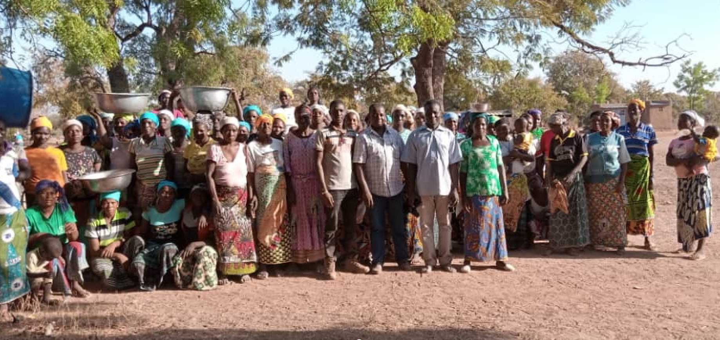

Konkourona, Burkina Faso as a proof of concept
FMCDP efforts began in Konkourona, Burkina Faso, as a proof of concept of what could happen if the needs of a single rural community were prioritized for development. Like many villages in the Sahel region, Konkourona has faced many complex and interconnected challenges. Some of these challenges lent themselves to solutions accessible to the community with relatively little support from government and non-government organizations:
- Primary education was ineffective
- Access to primary health care, including maternal and child care, was severely limited
- Water and basic sanitation were lacking
- Economic development opportunities beyond subsistence farming were limited
- Deforestation was contributing to desertification

Education
The founders of KAFO and MSN believe that education is foundational to peace and prosperity, however access is limited in Konkourona.

3.1.1 Past opportunities for education were limited
In 2019, education opportunities in Konkourona were generally limited to primary school. There were approximately 90 students per multi-grade classroom and few books for each subject taught. Teachers left Konkourona as soon as they could due to extremely limited housing and poor living conditions overall. Only 1 or 2 students per year passed the middle school entrance exam and were able to progress. Boys generally began lives of subsistence farming and girls were given by their fathers to older men in search of wives. There was no library and there were no reading materials available to those who were no longer attending school. There were no technical or high schools.

3.1.2 Present conditions are greatly improved
The effectiveness of Konkourona Primary School has increased significantly, thanks to projects implemented by KAFO and MSN from 2019 to today, such as: construction of new classrooms with electricity, reduction of class size from approximately 90 to 45, construction of housing for teachers, purchase of textbooks for each student and support for after school tutoring programs. In addition, an existing building was converted to a community library to provide access to reading materials beyond textbooks. Figure 2 shows a marked increase in the percentage of students passing the compulsory middle school exam. The difference between old and new classrooms is illustrated in Figure 3.
Figure 2: Percentage of students passing the middle school exam

Figure 3: Old (left) and new (right) classrooms
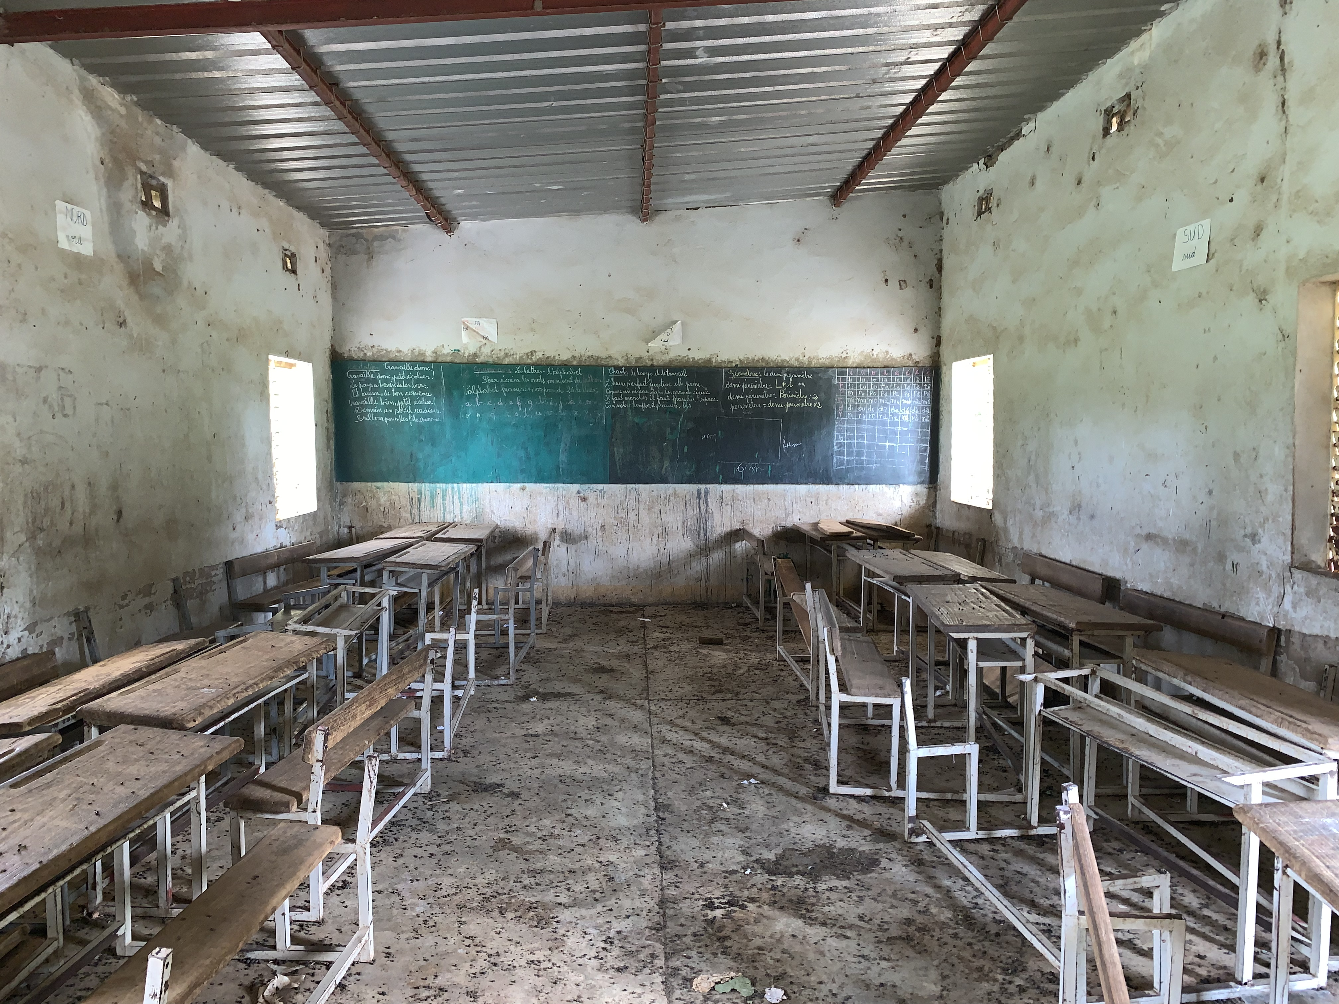 | 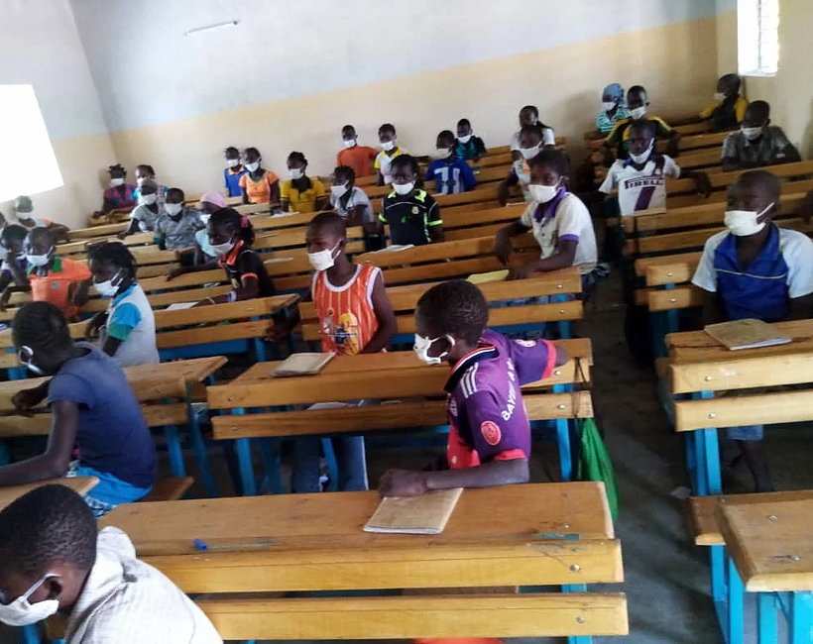

There was no middle school in Konkourona, so a new one was built by KAFO and MSN and it was opened in 2024 (see Figure 4). The school includes 4 classrooms, an administrative building, a security building, and latrines with a wash area. Only 7th grade was enrolled for the 2024-2025 school year to allow time for the new School Director to be established and begin operations. It is expected that all grades, 7th through 10th will be enrolled for the 2025-2026 school year with approximately 200 students, which is the full capacity of the school.
Housing for school administrators and teachers is in the process of being built and is expected to be ready in early 2025. Middle school teachers generally teach at several middle schools because unlike primary school teachers who teach all subjects, middle school teachers specialize in a single subject. Three houses have been built to allow the School Director and some teachers to live in Konkourona, but there are 9 teachers needed to teach all of the classes, so most teachers will not have housing in the village. KAFO and MSN will work with the School Director to understand what the needs are over time and consider building new houses if they are needed in the future.
Figure 4: New Middle School in Konkourona
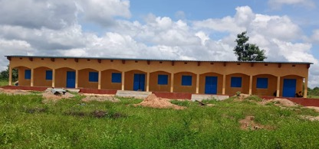

3.1.3 Future projects will expand opportunities further
The old, primary school classrooms still look the way they did when the photo on the left in Figure 3 was taken, and the school kitchen and latrines are in disrepair and unusable. There never was anywhere for students to gather for lunch. It is KAFO’s intention to support renovation of the old classrooms to fix cracks and leaks, repaint, repair desks, and add electricity, and make the kitchen and latrines usable again. There were further plans to build a pavilion for students to use for lunch. However, the community has other priorities, as communicated through MSN. KAFO and MSN will continue to work together to assess the most urgent needs and prioritize projects according to those needs. KAFO and MSN will support the renovations to the primary school and construction of a pavilion as soon as they are prioritized.
Our goal is for most students to eventually complete a technical certificate or high school baccalaureate (diploma) after middle school, but there is no technical school in the region and there is no high school in Konkourona. As the number of students successfully completing middle school rises, KAFO and MSN would like to build a technical school and a high school. When the elders in Konkourona designated a large plot of land to be used for a middle school in 2022, they included space for a technical school and a high school, so there is room for the desired expansion.
The schools being added will require construction of additional housing for teachers, administrators, and their families. It is also expected that housing for students traveling from other villages may be needed. KAFO and MSN welcome the chance to make Konkourona an educational center, with all of the potential employment opportunities that brings with it. In addition, it is recognized that it may be harder for some students to learn than others and KAFO and MSN are committed to working with teachers to make tutoring available at all levels to help overcome challenges some students may face. This is particularly important in communities in which parents may have little or no education and would not be able to help.
While schools are in the process of being built in Konkourona, KAFO and MSN will support students pursuing education beyond primary school by helping to pay for tuitions, transportation (bikes), books, etc., as students travel to other villages where schools are available. KAFO and MSN will also provide support for students who are accepted into universities and professional schools after high school, at the discretion of MSN leaders, as funding is available.

Healthcare
KAFO’s founders are dedicated to improving public health around the world, but there was no access to healthcare in Konkourona.

3.2.1 Past opportunities for healthcare were limited
Most, if not all, families in Konkourona have lost at least one child to preventable or treatable infectious diseases. The nearest hospital is approximately 50 miles away and smaller health posts in between are inconsistently staffed or equipped and unpredictable in costs, sowing mistrust in community members. As a result, people were more willing to accept death at home rather than take a long journey to a far-away place that could cost their life savings with unclear outcomes. The availability and costs of medicines and vaccines in other villages and towns were sporadic and unpredictable. The community desperately wanted high quality, dependable healthcare to be available in the village.

3.2.2 Present conditions are greatly improved
A primary health center, consisting of a primary care facility, a maternal and child facility, a pharmacy, latrines, housing for health workers, an incinerator and a laundry, was completed in 2022 (see Figure 5). Electricity and running water were installed wherever practical. The first baby, a girl, was born in the health center on 21-Dec-2022 at 11:46 pm, just prior to the official opening date of 22-Dec-2022. Once opened, the center immediately started receiving patients, who were grateful to have healthcare available in their community for the first time in their lives. There was a significant demand for vaccinations, and two more healthcare workers were hired.
KAFO partnered with an organization called Project C.U.R.E. to obtain a 40-foot shipping container filled with donations of medical equipment and supplies for the health center. That equipment and those supplies were very helpful in getting the health center up and running and there are many more materials available to prepare for the coming months and years. A warehouse for storage of equipment, supplies and medicines, and a landfill were constructed in 2023.
Preliminary data from the maternal and child center shown in Figure 6 demonstrate good health seeking behaviour in the community. Results over 100% show that there are many visitors to the health center from outside of Konkourona, providing the opportunity for increased revenue generation, supporting sustainability.
Figure 5: Primary health center
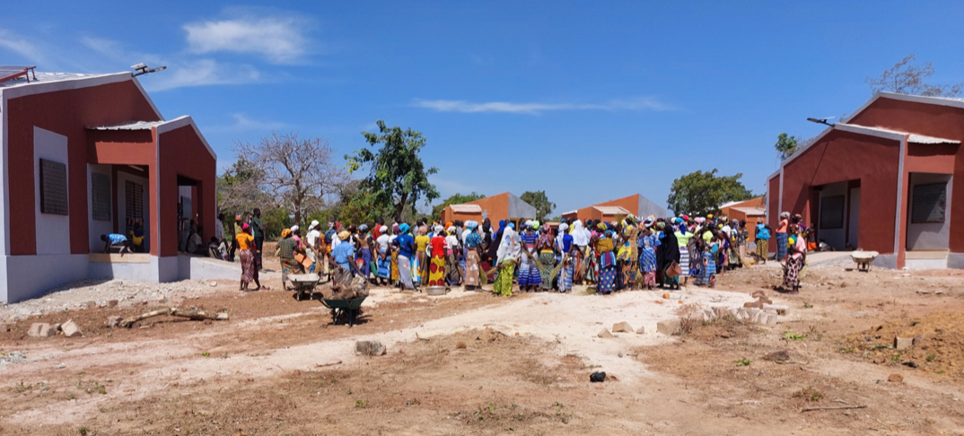
Figure 6: Data from the maternal and child center (Dec-2022 to Nov-2023)

* IMCI: Integrated Management of Childhood Illness
A Women’s Center with a kitchen, latrines and a hand washing facility was completed in 2024 to serve as a site for conducting vaccination campaigns, a waiting area for family members of patients and a center for women and youth (see Figure 7). Soon after completion, Dr. Clementine Tindano, Ophthalmologist, began seeing patients in the Women’s Center each week, providing a service that was not available to residents of Konkourona or surrounding villages previously. KAFO and MSN support evaluations for every student and adults pay modest fees for their evaluations. A summary of the outcomes from evaluations conducted so far is provided in Table 1.
Figure 7: Women’s Center
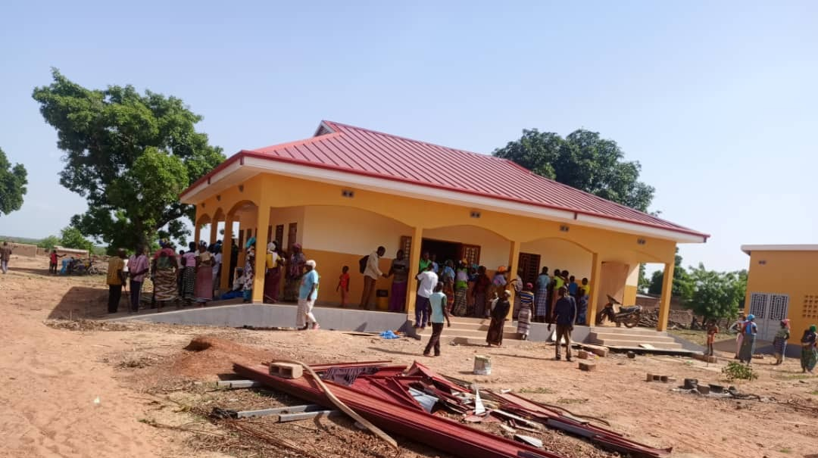

Table 1: Summary of Ophthalmology Findings
Date | Description | # Tested | # Treated | Treatments
Oct-2024 to Nov-2024 | Evaluation of students from 4 primary school classes | 122 | 58 | - Conjunctivitis  - Allergies  - Vision impairment
Oct-2024 to Nov-2024 | Evaluation of adults and children seeking help for vision problems | 68 | 53 | - Cataract surgeries  - Corrective lenses  - Conjunctivitis  - Dystrophy  - Glaucoma  - Macular degeneration  - Removal of foreign objects

Donations of toothbrushes and toothpaste were made possible through a grant from Colgate in 2024. Those materials are in the process of being shipped and will be used to begin an oral health program in 2025.

3.2.3 Future projects will continue to improve the new healthcare system
The District Medical Officer conducted an inspection of the health center in 2022 and made several recommendations for future expansions. The construction of the multi-purpose center addresses some of the recommendations, but there were two additional recommendations for:
- Additional latrines and showers
- Housing for the Pharmacy Manager
A diagnostic laboratory is also needed to guide treatment in the health center. There is an opportunity to partner again with Project C.U.R.E to obtain the equipment needed to get it started and replenish some of the materials and equipment initially provided.
In addition to ensuring that there is a physical health system in place in Konkourona, attention must be paid to the depth and breadth of care. KAFO and MSN would like to partner with other organizations to educate community members to make healthy lifestyle choices to help manage the quality of their lives. While basic care is available through skilled nurses and a midwife, KAFO and MSN would like to work with specialists like dentists, psychologists and other professionals to improve care in the community.

Water and Sanitation
Water is essential for life, but access to a reliable source of clean water was limited in Konkourona. In addition, the community must transition to use of latrines and away from open air defecation to keep the water and environment clean.

3.3.1 Past access to water and sanitation were limited
There were four shallow wells in Konkourona, but two were often empty during the dry period from October to May every year. All wells were contaminated due to open air defecation and openness to the environment, allowing microbes and wildlife in and necessitating that water be boiled prior to use. Women and girls spent a significant portion of each day traveling to wells and boiling water for cooking, bathing and cleaning.
Latrines were built at the primary school over 20 years ago, but have fallen into disrepair.

3.3.2 Present conditions are greatly improved
A reliable source of clean water was found and a tower was constructed in Konkourona in 2021 to feed the primary health center, the primary school, houses for teachers and healthcare workers, and three fountains throughout the community to serve approximately 75% of the population. Results of water testing demonstrated that the water was clean with no chemical or microbial contamination. A relay tower was built in 2022 to maintain adequate water pressure in the health center so that water would be reliable in the center on demand.
A new well was dug and a tower was constructed in 2022 to provide water to the new middle school that was planned for construction in 2023 and 2024. The new tower will also be used to provide water for the planned technical school and high school. Results from testing of the water from the new well also showed no chemical or microbial contamination.

A need for a third well was identified in 2024 to provide running water to new housing for middle school administrators and teachers and for new migrants to the community. That well and a fountain for the community are in the process of being built and are expected to be finished in early 2025.
The need for latrines is evaluated prior to each new project and latrines are incorporated into the project designs. Latrines have been constructed at the site of the health center, housing for teachers and healthcare workers, and the middle school, since development efforts began in 2019 to improve sanitation.
Figure 8: Old (left) and new (right) water sources
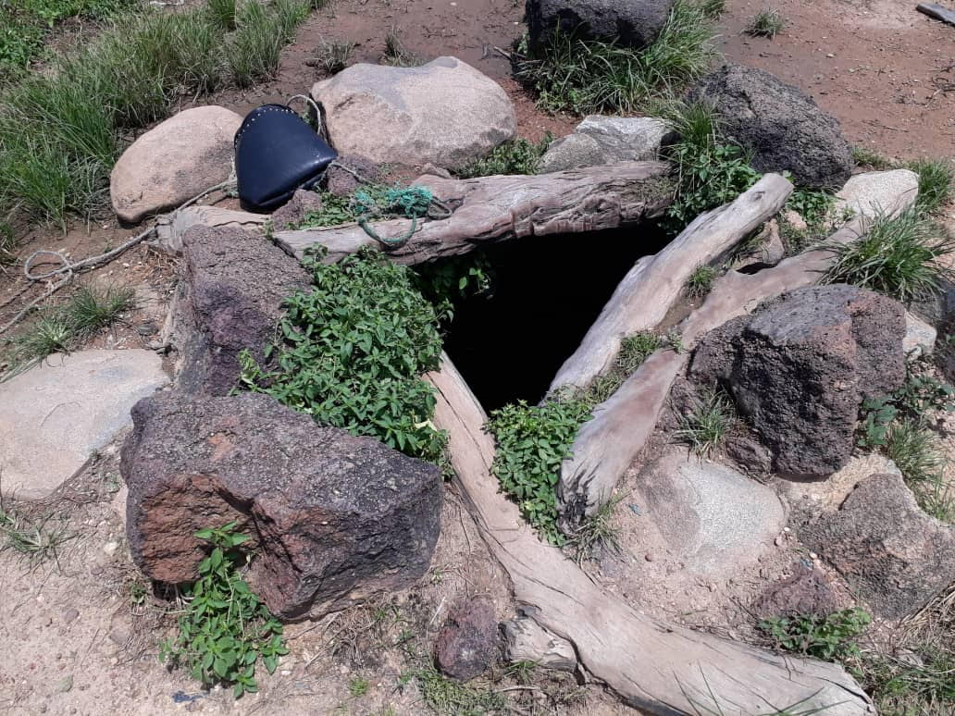 | 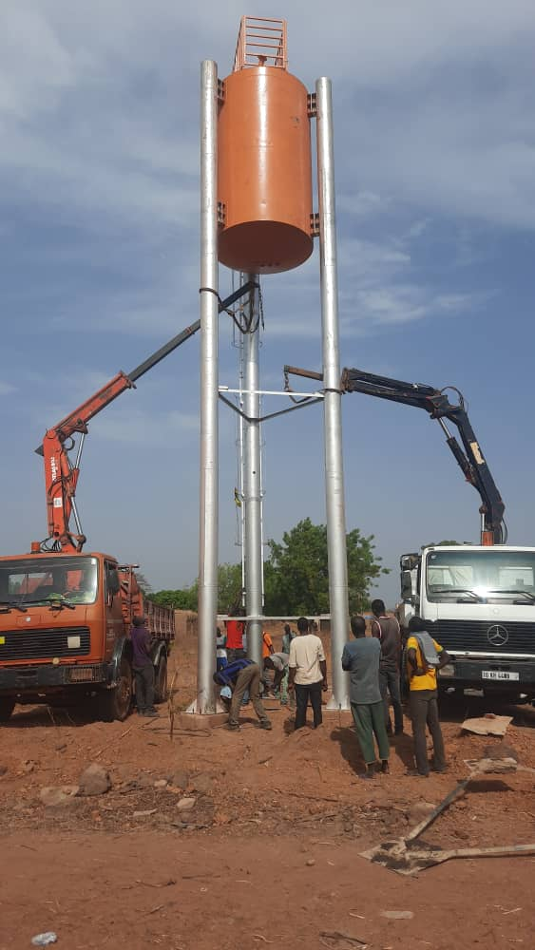

3.3.3 Future projects will continue to improve access to water and sanitation
Now that most citizens have reliable access to clean water, decisions will need to be made about further improvements of access. Only a single tap is available at the primary school for use by approximately 300 students, teachers and administrators. Access at the primary school should be expanded to include a separate hand washing station.
As new schools are constructed, proactive planning for continuous improvements in access should be considered to include installation of hand washing stations and running water in kitchens.
Latrines should be added with each new project and a plan for gradually transitioning the greater community away from open air defecation toward improved sanitation for everyone should be developed to ensure that the water source remains clean and to lessen the risk of the spread of disease.

Economic Development
Most families in Konkourona are supported by subsistence farming. Climate change is causing increased temperatures and more variable rainfall, which will make subsistence farming more difficult.

3.4.1 Past access to economic development opportunities were limited
The closest town to Konkourona is Lena, which is 11 miles away and takes approximately 2 hours to get to by bike because the road is unpaved. In addition to having higher-level education options, Lena offers opportunities for farmers to sell their crops. Crops harvested in October and November of each year often must last until the next harvest in the following October or November in order to feed the farmers and their families in Konkourona. The wisest farmers will save enough of their crops to last for two years in the event there are limited rains in a given season. However, there is no space for storage of crops away from rains and rodents. Most often families have small shelters that are primarily used for sleeping.

3.4.2 Present conditions are greatly improved
Developments from 2019 through 2022 have focused on improving access to education, healthcare, water and sanitation and have led to the creation of the following jobs:
- Program Director (1)
- Partnership Liaison (1)
- Water manager (3)
- Cleaners for the Health Center (10)
- Pharmacy Manager (1)
- Healthcare workers (5)
- Security (2)
- Accountant (1)
- Middle School Director (1)
- Teachers (9)
- Construction laborers (~400, as needed)

3.4.3 Future projects will continue to improve economic development
It is expected that farming will continue to be a primary occupation for families living in Konkourona and there is a great need for food throughout the country with approximately 2 million people being displaced as a result of jihadist activity along the borders. KAFO and MSN would like to work with the community members and partners to optimize growing and storage techniques to better serve the community itself and improve opportunities for revenue generation.
It is hoped that with increased revenue from farming and more alternative paying jobs becoming available in Konkourona, more members of the population will be able to pay other members of the population for goods and services, creating a self-sustaining economy within the community. Money will be infused into the overall economic system by selling crops in other communities, from the government through payment of teachers and health workers, and by visitors from other villages through payment for healthcare, medicines, vaccines, food, water and services like laundry, transportation, temporary housing, etc.
Additional opportunities to generate revenue are needed. KAFO and MSN will work together to explore the capabilities of the community members and the needs for goods and services in neighbouring villages and towns.

Energy and Environmental Protection
One third of Burkina Faso’s national territory is degraded, and that degradation is expanding every year.

3.5.1 Past access to energy and environmental protection solutions were limited
There is no electricity or natural gas available to most households in Burkina Faso, therefore, most families rely on wood for cooking. Konkourona sits at the edge of a protected forest, offering a vast territory for scavenging sticks and dead trees to burn. However, with the demand for wood being so great throughout the country, live trees are cut down too, which contributes to desertification in the region.
Few households had access to electricity or the conveniences that electricity brings, such as, lights for reading or doing homework or operating outside of daylight hours, refrigerators for longer term food storage, and use of computers or cell phones, to name a few.

3.5.2 Present conditions are greatly improved
Community access to electricity was greatly improved following completion of KAFO and MSN’s first project, new classrooms for the primary school. The new classrooms were equipped with outlets, lights and fans for use during classes earlier in the day and during tutoring sessions held each night, all powered by solar panels installed on the roof. Each project since then has incorporated addition of solar electricity to include housing for teachers, the water towers and fountains, the health center, the library, the KAFO headquarters, the Women’s Center, and the Middle School.
One thousand one hundred fruit and shade trees were planted in 2022 to begin reforestation efforts around Konkourona. Once grown, the trees will provide food for the community, economic development opportunities through sale of the fruits, and shade to protect the population and the land from the intense sun.

3.5.3 Future projects will continue to improve access to energy and environmental protection solutions
Several new schools, administration buildings and houses for teachers are planned for Konkourona, each of which will include solar electricity as a standard. Additional opportunities to plant trees will also be explored.
An alternative source of energy for cooking is needed urgently to stop deforestation around Konkourona and throughout the country. KAFO and MSN will look for partnerships to help solve this need.

Sustainability
Central to all of the development efforts started by KAFO and MSN is that they be sustainable. Revenue generating activities and good management practices must be in place to support that sustainability. The KAFO Program Director, who is also the MSN Vice President and Treasurer, is responsible for regular monitoring of all improvements to ensure that any defects are identified and repaired, if under warranty, or other means if the warranty has expired. If MSN does not have sufficient funding to cover a repair, the need should be raised to KAFO in a Joint Leadership Team Meeting for evaluation for support. A Maintenance Manager was hired in 2024 to make monthly visits to Konkourona and repair everything that has been identified as requiring it or coordinate repairs beyond his capabilities.
MSN has identified a need for computers to support management of all of the improvements in the community. KAFO partnered with Business Online to obtain computers, which were installed in the library in Konkourona. KAFO and MSN supported computer classes to help community leaders setup what is needed to improve program monitoring activities.

Education
Several activities have been standardized to help support sustainability of education improvements in Konkourona.
- Teachers pay a monthly rent for their housing to MSN to be saved to conduct minor repairs.
- Middle school and high school students pay a rental fee for books, a portion of which is returned at the end of the school year if books are returned in good condition to encourage sharing of books among students.
- Families pay a small fee to become members of the library, which supports purchase of new books.
- People pay a small fee to print documents at the library, which pays to replenish paper and ink.

Healthcare
The Health Center represents a significant revenue generating opportunity, if it is managed well.
- Patients pay a small fee for appointments with healthcare providers.
- Fines are paid for community members who require healthcare as a result of violence towards each other, such as in fights or abuse within families.
- Patients pay for medicines and vaccines.
- Healthcare workers pay a monthly rent for their housing to MSN to be saved for minor repairs.

Water and Sanitation
Revenue collected from the sale of water at the community fountains and housing for teachers and healthcare workers will be used for repairs to the water pumps and the solar panels used to power the pumps, as needed. The MSN Maintenance Manager will be responsible for regular monitoring of latrines to ensure that any problems are identified and addressed.

Economic Development
Members of MSN currently provide monthly dues to support MSN projects and promote further development in the community. As new opportunities for economic development are identified, ways to promote further development will be considered.

Energy and Environmental Protection
A sustainable source of energy for cooking must be identified and developed. If a solution is found, it has great revenue generating potential.
A pilot program to cultivate fruit trees in the community is in progress, the result of which will take several years to reach fruition. If successful, the trees will provide food for the community and a source of revenue of the fruits can be harvested and sold, either fresh or in jars or cans.

Scaling up beyond Konkourona
Remote villages throughout Africa face many of the same challenges present in Konkourona before KAFO and MSN partnered to drive improvements. KAFO founders would like to expand upon successes realized in Konkourona through continued focus on three pillars for development in other villages: education, healthcare, and water and sanitation. Two additional pillars, economic development and the environment, are inseparable from the original three when considering long term sustainability, and will also be core to KAFO’s future plans. Strong partnership with the village association has been foundational to successful development efforts in Konkourona and must be core to any future efforts.
Implementation of the FMCDP in other villages will require identification of a partnering village, establishment of a community association if none exists, completion of an assessment of needs in consideration of the five pillars and in partnership with the village association, execution of projects, and monitoring to ensure success and sustainability. A summary of the FMCDP intended for implementation in other villages in provided in Table 2.
Table 2: Summary of the FMCDP for implementation in other villages
Step | Description
1 | Identification of potential villages for development by working with existing partners in Africa (e.g. MSN, SCMS, Friends of African Village Libraries, the Bobo-Dioulasso Rotary Club, etc.)
2 | Formation of a village association to lead development efforts
3 | Assessment of needs for improvement in 5 key areas:  - Education  - Healthcare  - Water and sanitation  - Economic development  - Environmental protection
4 | Execution and Monitoring of FMCDP

Corporate capabilities
Konkourona Alliance Foundation (KAFO), Inc. is a non-governmental charitable organization, incorporated in the United States of America with 501(c)(3) status. KAFO has established a strong track record of delivering on its commitment to support the development of Konkourona by partnering with MSN to improve access to primary education, healthcare, water and sanitation, employment opportunities, energy and environmental protection. KAFO is the first non-governmental organization, in the history of this sub-region of Burkina Faso to make this level of contribution to the development of a village, making it an example that has the potential to encourage other villages to seek the same partnership. Following success in Konkourona, KAFO aims to expand its reach to other villages within the Sahel.
KAFO’s leadership is made of volunteers from Burkina Faso, the US and Switzerland, currently living in the US, Switzerland and Ghana. They have proven success in development projects and public health leadership positions at local, national and/or international levels, including providing direct healthcare, leading national immunization programs, and leading registration of vaccines to prevent the spread of infectious diseases worldwide. KAFO leaders use both conventional and innovative approaches to their work to meet the world’s growing healthcare needs.
KAFO works with MSN in Konkourona, which is legally recognized by the Government of Burkina Faso as a tax-exempt charity organization. MSN is a community-based association setup initially for partnership with KAFO on development and will be critical to sustainability following of any improvements. The Association mobilizes the members of the village to identify the key priority programs, provides local labor for the construction projects, and ensures community support for education, healthcare, water and sanitation, community development, energy and environmental protection efforts. KAFO and MSN’s technical partner, Mamadou Tindano, owns a nationally renowned construction management company with an excellent track record of delivering high quality buildings, bridges and other major construction projects in Burkina Faso and surrounding countries. Close partnership with a village association like MSN is seen as critical to successful development and sustainability in any village and formation of such an association will be a prerequisite to KAFO involvement.
Several visits from regional health, education and administrative authorities have taken place, during which they provided strong encouragement and confirmed their support to appoint teachers and healthcare personnel to Konkourona, as needed.

Figure 9: MSN Association supports work in Konkourona
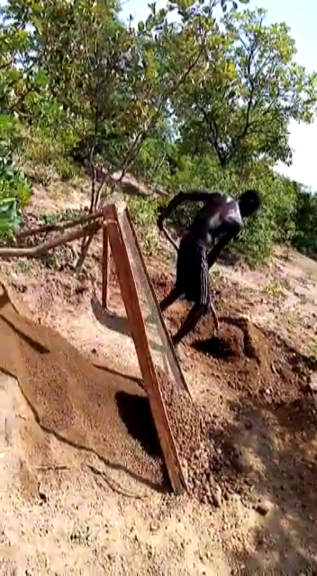 | 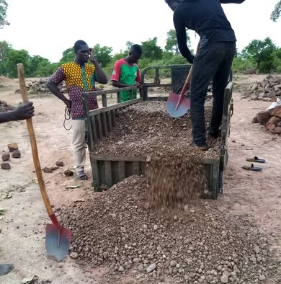 | 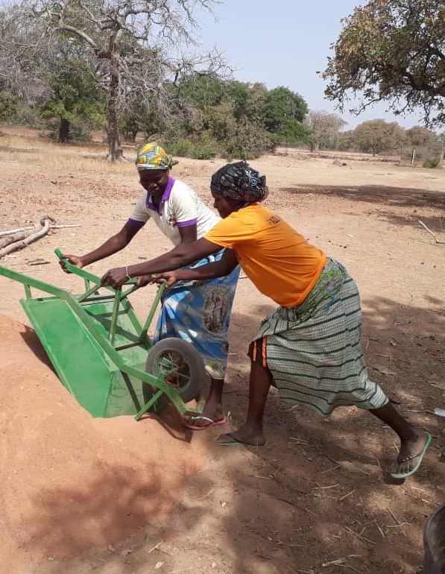

Partnership with other non-governmental organizations
KAFO and MSN are seeking opportunities to partner with other funders and non-governmental organizations, such as, Friends of African Village Libraries and Rotary International to maximize opportunities in Konkourona and expand the FMCDP to include other villages.

Timeline and spending for completed projects
2019 | 2020 | 2021 | 2022
Start-up 501(c)(3) nonprofit  Begin construction of 3 new classrooms and an office for teachers  Purchase books and learning materials for each student  Implement tutoring program | Complete construction of 3 new classrooms and an office for teachers  Complete construction of housing for teachers  Drill well for community and health center  Begin Sponsor a Child Program | Build water towers and fountains for community and health center  Begin construction of Health Center  Health Center equipment and supply donations  Sponsor a Child Program | Complete construction of Health Center  Complete construction of library  Plant 1100 trees  Build water tower for middle school  Health Center equipment and supply donations received  Complete construction of KAFO headquarters in Konkourona  Health Center medicines and vaccines  Open Health Center  Sponsor a Child Program
$73,613 | $234,714 | $864,839 | $291,269

2023 | 2024
Complete construction of middle school, administration building, security building and latrines  Begin repairs to Health Center  Begin construction of a multi-purpose center, kitchen and latrines  Sponsor a Child Program | Open middle school  Begin construction of housing for teachers  Continue repairs to Health Center  Begin repairs to headquarters building  Complete construction of multipurpose center (Women’s Center)  Install water relay tower for Women’s Center and surrounding buildings  Begin Ophthalmology program  Sponsor a Child Program
$262,841 | TBD (Fiscal year ends Apr-2025)

Overall timeline and budget for major projects
2025 | 2026 | 2027 | 2028 | 2029 | 2030
Drill well for housing for middle school teachers and surrounding community  Complete construction of 3 houses for middle school teachers and administrators  Make repairs to housing for primary school teachers  Construct soccer field  Begin construction of a diagnostic laboratory for the Health Center  Complete repairs to Health Center and KAFO headquarters  Begin Dental Program | Complete construction of diagnostic laboratory and open  Complete construction of high school classrooms and latrines and open | Complete construction of housing for teachers for high school  Build internet tower | Construct additional latrines and showers for health center  Construct kitchen, pavilion and athletic area at the site of the new middle school and future site of the high school and technical school  Complete repairs to primary school, add pavilion | Complete construction of technical school  classrooms and latrines and open | Complete construction of offices, kitchen, and housing for teachers for high school  Complete construction of library for middle school, technical school and high school
Sponsor a Child Program, Ophthalmology Program, Dental Program, Tree Planting Program, Alternative Energy Program, Healthcare Optimization, Maintenance Program
~$200,000 | ~$200,000 | ~$200,000 | ~$200,000 | ~$200,000 | ~$200,000

FMCDP long term strategic framework
The theory of change for KAFO’s longer term is based on the belief that once a core number of communities achieve the five key development goals (education, health, water and sanitation, economic development, and energy and environmental protection), it will create a cycle of positive change.
As a longer-term strategy, KAFO envisions expanding the FMCDP concept in partnership with MSN and other NGO’s. Capacity building would be provided by KAFO and MSN initially, and as more FMCDP communities join, the local NGOs developed to manage the new projects work would become part of the capacity development network. The ultimate vision is to develop a FMCDP network that can continue to expand across different locations and countries. In addition to establishing the FMCDP networks, the expansion would eventually include a capacity development package that could be delivered via NGOs, and bi-lateral or multi-national agencies as part of larger initiatives.
To maintain momentum, the near term includes a strategy whereby other FMCDP locations will be identified and a strategy similar to the Konkourona project will be developed. The needs of each community will be different; however, the approach will remain based on the five pillars of education, health, water and sanitation, economic development, and energy and environmental protection. A phased-approach for bringing on additional FMCDP communities will be necessary in the short term. This is both a reflection of KAFO’s currently small number of staff, limited funding, and also the need to refine the approach and capacity development strategy through additional experience. The phase-in approach is shown below.
Location | 2025 | 2026 | 2027 |  | 2028 | 2029 | 2030 | 2031
Konkourona, Burkina Faso | Step 4: Execution and Monitoring
Next village |  |  |  | Step 1: Identification |  | Step 2: Formation | Step 3: Assessment | Step 4: Execution

