
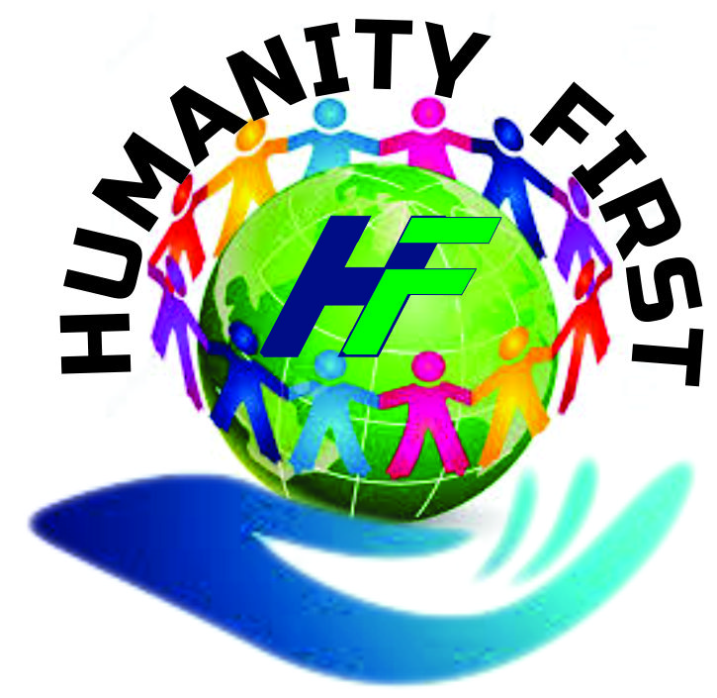
P.O. Box 114 Kumba
Reg. 166/2022/DR/C19/SAAJP
MOTTO:To Love is to Serve
Email: kumbahumanityfirst@yahoo.com
Tel: +237676246818/+237677023029

Wednesday 14th Sept. 2022
PROJECT TITTLE: BRING WATER SAFE LIVES
PROJECT BACKGROUND: HUMANITY FIRST ASSOCIATION OF CLEANERS (HUFAC) - CAMEROON is a registered community based organization which aims at bringing relief to the most vulnerable peoples in need. It is made up of volunteers with diverse skills set offering their services as charity since 2019.
OUR MISSION: Serving Humanity with Love (by doing little things with passion, dedication & commitment).
OUR VISION: To inspire more people to engage by the little things we do to response positively to the plight of the less privileged.
OUR CORE VALUE: Human Being (God’s Creation)
OUR FOCUS: The sick, elderly persons, IDPs, refugees, physically challenged, women and children in distress, education, health, vocational training & empowerment, hygiene and sanitation, environmental protection and agriculture.

CONTEXT AND JUSTIFICATION
- Context
Mahole village is located in Kumba three Sub-Division, Meme Division, in the South West Region Cameroon. It is about 15km from the main town Kumba. The local climate and environmental condition of the area is very conducive for agriculture especially cash and food crops production, with consistently average temperatures throughout the year. Soil fertility is also excellent and can support diverse and intensive crop production.

However, the economic and social development of the region is relatively limited. Nearly all households in the village practise subsistence agriculture, trading only small quantities of excess goods at the Fiango & nearby markets. Living conditions are typically basic.

The on-going conflict between state Armed groups and none state armed groups has caused an influx of vulnerable women, children and youths who have flee their villages to seek refuge in safer areas as internally displaced persons (IDPs). With a population that used to be around 12,000 before 2017, now roost to about 23,000 in 2022 This has compounded the hardship in the area in particular and the region as a whole.

Consequently, livelihoods and employment opportunities in the area are very limited. With low incomes, only a minority of the population can afford the fees to send their children to schools in secured areas, let alone to support them with uniforms and exercise books. Health problems are also widespread with malnutrition and protein deficiency, no portable clean water, hygiene and sanitation constituting the main problems.

Politically and organisationally, the village is harmonious and has cooperated to implement a number of small projects to improve local living conditions. Local leaders are also eager to improve the circumstances of the village & other surrounding villages & communities. And in fact bringing water in these communities wills indeed save lives; in fact, this falls in line with the UN SDGs

In short, Mahole village is marked by considerable poverty and unemployment rate. However, it has both the natural resources and the human desire to take the next step on the development ladder

- Justification
Mahole village was selected amongst many other villages for the following reasons,

- First, because of the increase of the population from 12.000 to 25.000 inhabitants

- Second, because of the climatic and soil fertility opportunities for more intensive and effective crop production, attracting hundreds of IDPs and other strangers to the village. Therefore increasing water demand
- Third, the distance covered by this villagers to fetch water is about 3.5km
- Fourth, insecurity coursed by the on-going conflict resulting to kicknappins, Rape, stray bullets etc.
- Fifth, accessibility is poor, & crowding to the lone water site resulting to fighting amongst children and even adults some times, many accidents recorded.
- Sixth, apart from the immediate community benefiting, the surrounding villages, strangers & passer-by will benefit indirectly as well.

The overall impact of the project is therefore to save lives, reduces access, improve the livelihood of the entire village and neighbouring villages as well as other vulnerable communities.

OBJECTIVE: the primary objective is to bring portable clean water in the village & surrounding communities, to reduce suffering, reduce the rate of health related cases resulting to poor water condition, and to save lives, which is very important, as it is said “water is Life”.
BENEFICIARIES
The Mahole villagers are the primary beneficiaries of the project while neighboring villages and environs including visitors and passerby will benefit indirectly. With a population that use to be about 12.000 in 2017 now roost to about 25.000 in 2022 making it very difficult for the population to manage the limited source of drinking water. There is an urgent need for water to be brought to that community.
BUDGET
AMOUNT = $ 40000
COMMUNITY LABOR = $ 5000

BUDGET BREAKDOWN
No. | ITERMS | UNIT COST | TOTAL | OTHERS
1 | Drilling of bolt holes 3 | $ 6000 | $ 18000
2 | Materials | $ 12000 | $ 12000
3 | Plumbing | $ 3000 | $ 3000
4 | Transportation of material & other Items | $ 2000 | $ 2000
5 | Administrative cost | $ 5000 | $ 5000
6 | Community Labor | $ 5000 | $ 5000
7 | Total cost |  | $ 45000

CONCLUSION
When you look closely you will realize that the Mahole community is going through a lot in the absence of clean portable water. This has been for many years though there are many other villages with similar situations but thought we should begin with MAHOLE looking at the scale of preference, considering the increase of vulnerable population into the community. If the above amount is raised, Global Giving will not only be bringing water to this community and it’s environ, but it will equally be SAVING lives as well. This will give HUFAC the opportunity it has been looking and, waiting for a long time now to assist the above mentioned community & surrounding villages. We are sincerely looking forward to having your support & generous donations towards the success of this project.

