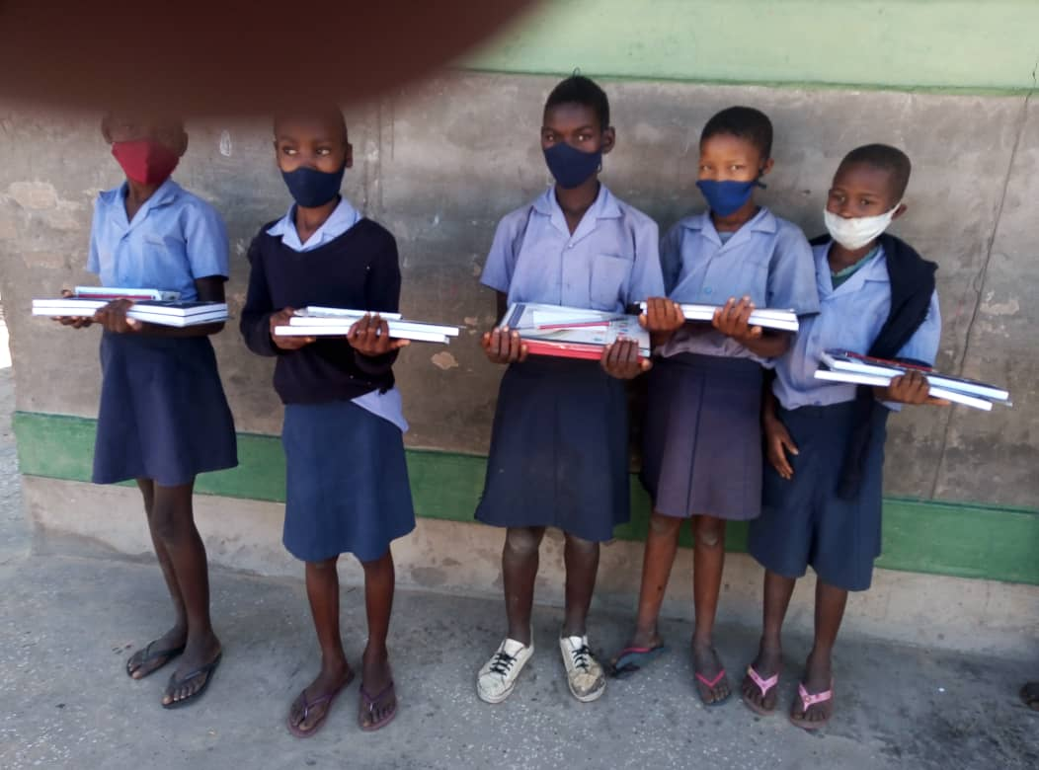  Supporting vulnerable children creates more adaptive, productive, and healthy adults. These adults have healthier cognitive and character traits later on. Children with proper support also translates into a future society with reduced crime, increased workforce productivity, lower teenage pregnancy, and the development of other positive character traits. Most importantly, it creates stronger future families.
  Who We Are
  After School Programme for Orphans and Vulnerable Children (ASPOVC) is a welfare charitable non-profit organization run exclusively by volunteers. We work together with international and local partners on collaborative children development projects.
  About Us
  EQUITY, INTEGRITY, ADAPTABILITY, INCLUSIVITY, Empathy
  Contact Us
  Phone: +26481 378 8083
  Email: ovceenhana@gmail.com
  Web: Web address
  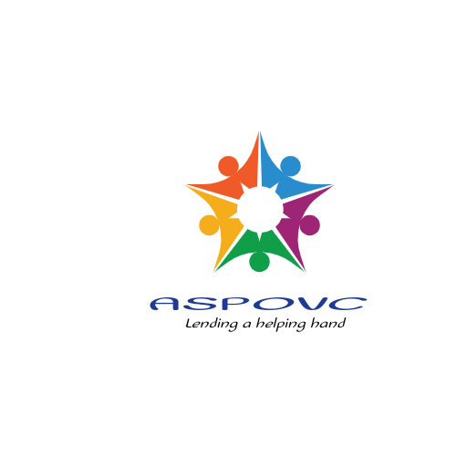 | Organization Name  ASPOVC  Private Bag 88004, Eenhana, Namibia
  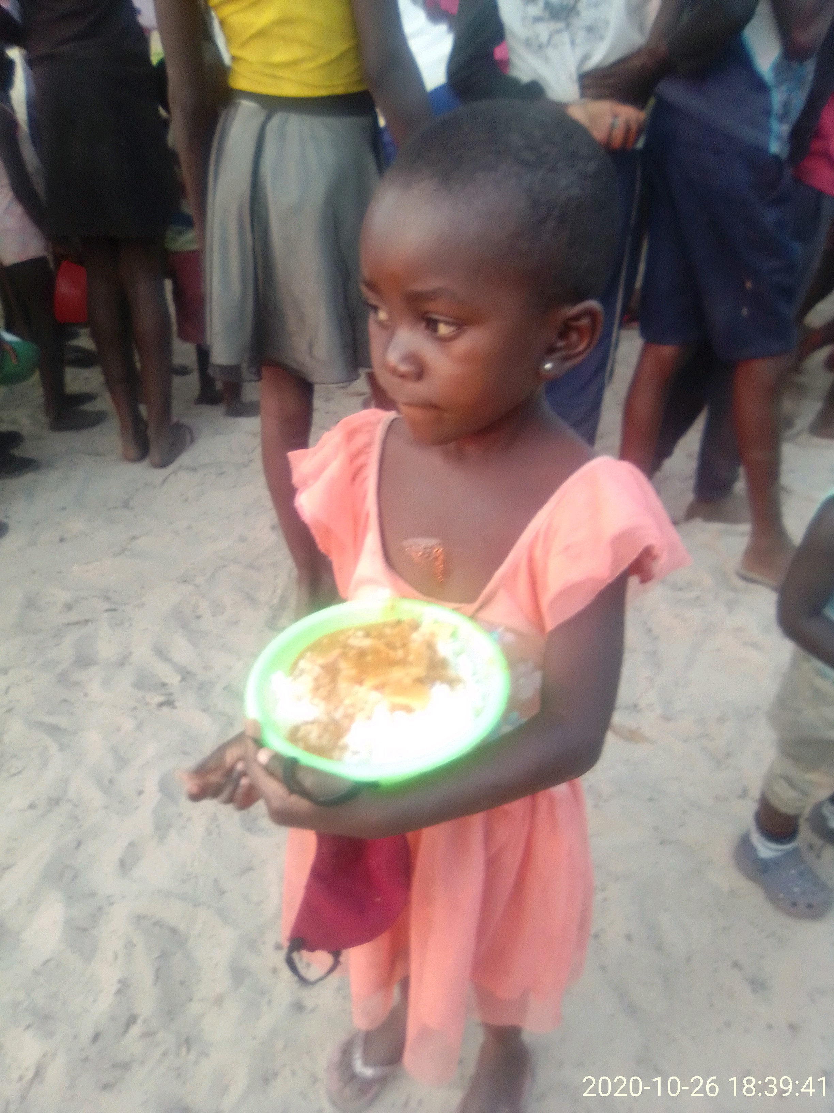
  Organization Name
    - After School Programme for Orphans and vulnerable Children-ASPOVC
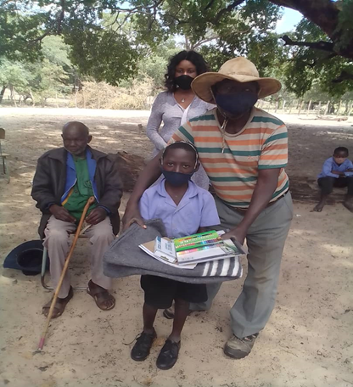  Many adults with character flaws and chronic health and emotional struggles were once healthy children. Studies show early intervention in the lives of disadvantaged children is far more effective than rehabilitating them.  What we do  We seek to respond effectively to the plight of children, providing interventions that will result in their Physical, Psychological, Social and Emotional wellbeing and development. | ‘’We learned that orphans are easier to ignore before you know their names. They are easier to ignore before you see their faces. It is easier to pretend they’re not real before you hold them in your arms. But once you do, everything changes’’. –David Platt  Every child needs food, clothing, and shelter to survive. They need much more than that to thrive. Help children receive the resources they need to grow into capable adults that can create strong homes in the future. There is also nothing quite like seeing a child smile who hasn’t for some time.  How can we do it  We team up with individuals, organizations, foundations, and companies to empower local children’s organizations with resources so they can better support the children in their care. | 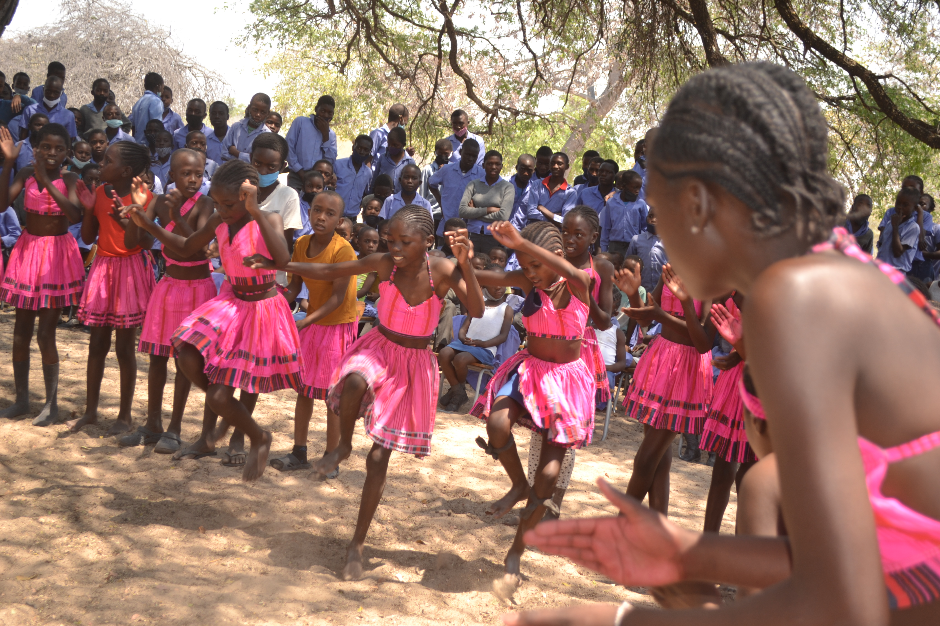  Cultural awareness helps children break down cultural barriers, build cultural bridges, and learn how to love, and appreciate those different from them. They can relate better to people with cultural differences as they begin to understand themselves better. This results in more cultural connection and less cultural conflict.  Our Products and Services  - On -site (school/family) counseling and psychosocial support  - Family/group based support in and with academic homework  - Child support services for legal documentation  - Referrals programs  - Feeding scheme  - Extra -curricular activities (Sport, Art, Music, Dance, Poetry and Drama)

