IMPLEMENTATION
of the
DASSA FARM in BENIN
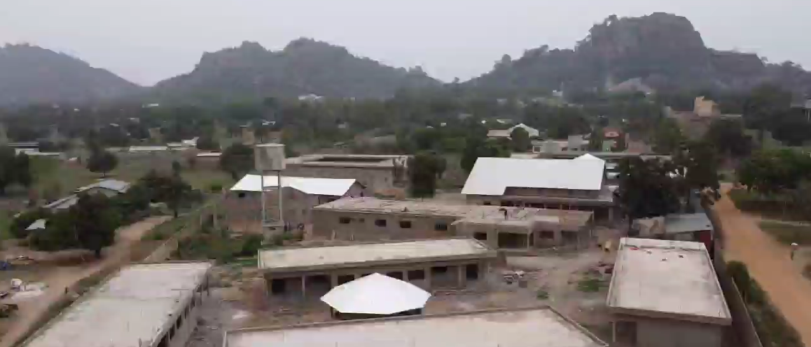
The new psychiatric care center in Dassa

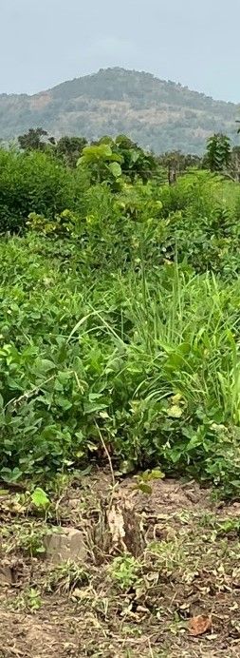

A project of
LES AMIS de la SAINT-CAMILLE
to support its African partner
l’Association Saint-Camille-de-Lellis

in partnership with :
À la Croisée des Chemins (France)
Agence territoriale du développement agricole-ATDA (Bénin)

L’ASSOCIATION SAINT-CAMILLE-de-LELLIS (ASCL)
According to the traditional African understanding, people with mental illness are possessed by an evil spirit, they have been bewitched. Their delirium, or unusual or bizarre behaviour, are thus interpreted. Members of the community keep their distance; no one dares touch them for fear of being bewitched in turn. In cities, they wander the streets, destitute and abandoned; other people keep their distance from them, abandoning them to their sad fate. In the villages, people with mental illness are still too often chained to a tree at the edge of the village and will sometimes remain there until death. Some sects tie them to trees, claiming they can rid them of their evil spirit by punishing their body. The following report from the New York Times in October 2015 illustrates this: https://www.youtube.com/watch?v=uKd9MxBzAUc

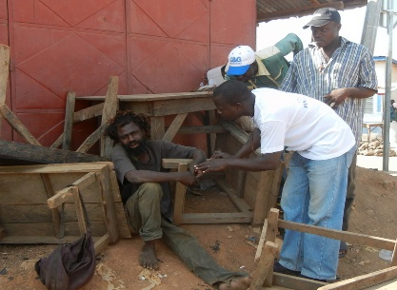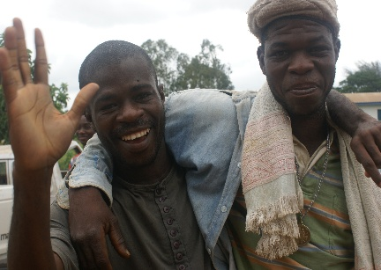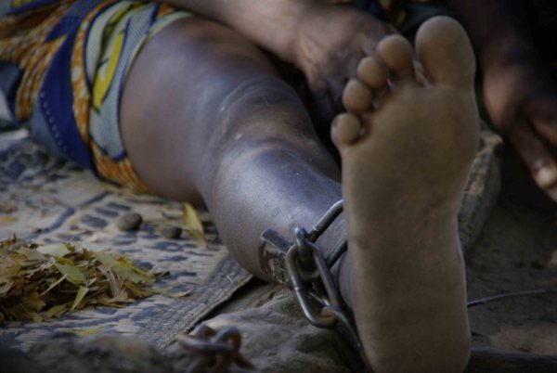

Thanks to the hard work of its founder, Grégoire Ahongbonon (a Beninese man), the Association Saint-Camille has been helping and advocating for these people for more than 30 years. It has established an important network of psychiatric care services (see map in appendix, depicting service locations in Benin). Three centers currently welcome people with mental disorders in Côte d'Ivoire, four in Benin and three in Togo. Diagnosed by a specialized nurse, they are cared for using a modern approach, surrounded by caregivers (almost exclusively ex-patients who have recovered) who provide a supportive and loving environment. At the end of their journey, depending on their progress and personal needs, a certain number are referred to a companion rehabilitation center (to learn a trade, to increase their physical conditioning, to resume work habits, etc.) before returning to their community of origin. A network of outpatient clinics ensures medical follow-up. These clinics also provide the opportunity for many new patients to be cared for in their home environment.
In Benin in 2021, 4,649 patients received residential care at one of these centers and 100,762 outpatient consultations were provided. It is estimated that, since 1991, more than 140,000 men and women have benefited from the care that this organization provides in the three countries mentioned above; most of them are now active in their communities. The Association Saint-Camille relies solely on donations to operate: no government funding is provided.

Les AMIS de la SAINT-CAMILLE :
Nearly 1,400 Friends in Canada and USA (mostly in Quebec) belong to this charitable organization, which is legally recognized by Corporation Canada.
About ten people serve as volunteers in different roles within and in support of the Board of Directors. They carry out awareness activities in a variety of settings: schools and universities, parishes, religious communities, businesses, conferences, kitchen and neighbourhood meetings.

Les Amis serve two goals:
- To inform and educate our population about the mental health situation in sub-Saharan Africa and the modern solution offered by the Saint-Camille Association.
- To develop a network of individuals, organizations and partners who can provide resources to Grégoire Ahongbonon and his team on three levels:
- Training: staff training, interns, support and care professionals;
- Material resources: medical equipment, medicines, care materials, well drilling, construction or renovation of buildings;
- Financial resources: construction projects, local training for staff, vegetable gardens, agricultural and social development.

All donations are forwarded in full (100%) to the Association Saint-Camille in Africa.

The experience in management, helping relations, financing and psychiatry of the members of the Board of Directors is an added value as it allows them to better support the Saint Camille. Since 2001, Les Amis has gotten to know its African partner, working closely with it, discussing and exchanging approaches to project development and establishing a good alliance.

THE PROJECT :

At Dassa, located in the center of Benin, the Association Saint-Camille is building a large center to care for people who have both drug addiction and mental illness (see photo on the first page). This particular clientele is present in the ten psychiatric residential centers. They often disturb the other patients who are treated there. They need a different approach, which is known in psychiatry. This will be the only center in French-speaking West Africa to offer such a service. It should receive its first patients this year (2023). Its construction is financed by the Italian Episcopal Conference, as well as a Spanish association.
In the structure of ASCL's services, the majority of the ten residential centers in the three countries mentioned above are associated with a nearby rehabilitation center. The leaders of ASCL have decided that for the center of Dassa, this will take the form of a farm. They called upon Les Amis de la Saint-Camille for its financing. A 17-hectare plot of land was purchased last year and notarized. This area is agricultural. It has sandy-silt soil with good rainfall in two rainy seasons.

Three goals will be pursued at this farm:

- Reintegration, i.e. preparing male and female patients to return to their environment at the end of their treatment. For the men, it will be a matter of improving their physical condition by working on the plantation an increasing number of hours per week, learning new agricultural techniques, for those who come from rural areas (composting, crop rotation, etc...), developing work habits (starting and finishing on time, accepting the boss's instructions, etc...). Women will resume participation in the agricultural work traditionally reserved for them (sowing, transplanting, harvesting) as well as in traditional responsibilities lost due to illness (cooking, washing, small vegetable gardens, etc.).
- Increased food self-sufficiency : the food grown at the farm will help feed the patients at the psychiatric care centers, thus reducing the costs of purchasing food products. The planned crops will be varied and attention will be paid to protein vegetables, too often lacking in patients’ diets. Thus, both the quantity and quality of the food will increase.
- Raising revenues to help cover the numerous needs of the ASCL (personnel salaries, purchase of medicines, transport, etc...) via the sale of the harvested surplus. This helps fulfill a long-standing objective of the Saint-Camille Association, which has been the object of considerable efforts. The less our partner is dependent on foreign income, the less its sustainability will be a source of concern.

Strengths of this project:
Three elements enhance and promote realization of the project:

- Loïc Coudière, leader of the French association "À la Croisée des Chemins", agronomist-farmer in early retirement, partner since 2007 of ASCL, will be the project manager and will answer for it, together with his wife Antoinette. They will live in Dassa for the next several years. They have sent a container of agricultural equipment and supplies by boat for this project in December 2022. Both have made preparatory visits to Dassa over the past six months. Loïc and the leader of Les Amis have known each other well for more than ten years and are working on the project with Grégoire, the ASCL leader. Through his association, Loïc has also pioneered the development of the Agoïta farm (see below).
- The Agence Territoriale de Développement Agricole (ATDA) of the Beninese Ministry of Agriculture, Livestock and Fisheries (MAEP) is involved in this project. Meetings and exchanges have taken place between Loïc and Mr. Adolphe Agbo, director of the regional ATDA and Mr. Eugène Alissou, former director. Both support the project and are available to provide support. Discussions have focused on climate conditions, crop rotation and on the production of particular crops (soybean, corn, banana, pigeon pea and market gardening), using technical and economic data sheets. The ATDA encourages and supports quality agricultural development and will act as a consultative and expert body for the smooth running of this project, both during its implementation and in the years to follow.
- The Association Saint-Camille has owned a farm in Agoïta (68 hectares) near Bohicon (about 75 km south of Dassa) since 2009. As mentioned above, Loïc has played a major role in its development (agricultural instrumentation, establishment of the palm grove, banana plantation as well as market gardening and food crops - rice, cassava, corn, etc.). More than 50% is under cultivation, the rest is still under development. A Spanish association, Moianes Solidari, supports the farm's management team. In short, both ASCL and Loïc are experienced in tropical agriculture.

Project Activities:

1) As soon as funding permits, construction of the farm building will begin (probably in March). The building will house 20 staff and patients undergoing rehabilitation. The construction will include toilets, showers and a pit (latrine). The area is currently cleared and ready for construction.
2) The next step will be the clearing of the rest of the land: weeding and removal of stumps to allow for cultivation. The work is planned for April, giving time for Loïc and his wife to arrive and settle. The 17 hectares of land is composed of two adjacent parcels bought and notarized.
3) The installation of the solar electrification and the irrigation system with the pump will come later.
4) The last step will be the seeding and transplanting: banana, cassava, corn, pigeon peas and a significant market garden production (tomatoes, onions, peppers, etc...).

N.B.: - The drilling of the well has been completed, as well as the construction of the water tower.
- Two people will be trained at the Songhaï agro-ecological center in Porto-Novo, Benin (https://fr.wikipedia.org/wiki/Centre_Songha%C3%AF)

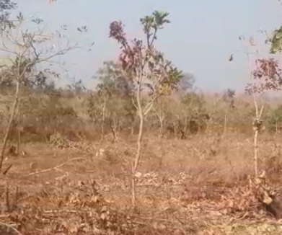
A view of the wild land

Funding needed:

- Building (plans available): .................................................. $124,870
- Land clearing (Mission Inclusion – in hand).......................... $10,000
- Solar Electrification: ........................................................... $37,000
- Irrigation system: ................................................................. $39,000
- Latrines, showers: ................................................................ $36,000
- Plants and seeds (anonymous donation – in hand):............. $5,000
- Songhai training: ................................................................... $5,000
________

TOTAL : ...................... $256,870

In short...

This project will complete the structure of services present in the Saint-Camille approach for people being treated in residential care. At the end of their journey, depending on the needs of each person, many will be moved to this reintegration center to prepare for their return to their community. This transition will mark another step in their journey.
In addition, the farm will contribute to the search for sustainability of the Association Saint-Camille, i.e., it will become more autonomous and therefore less dependent on external resources to ensure its continuity in the years to come.
Through this initiative, Les Amis de la Saint-Camille will have made another significant contribution to the development of its partner, with the ultimate goal of supporting it in the modern psychiatric services provided to people whom Grégoire rightly calls "the forgotten among the forgotten".

Jean-Paul Cyr, pres.

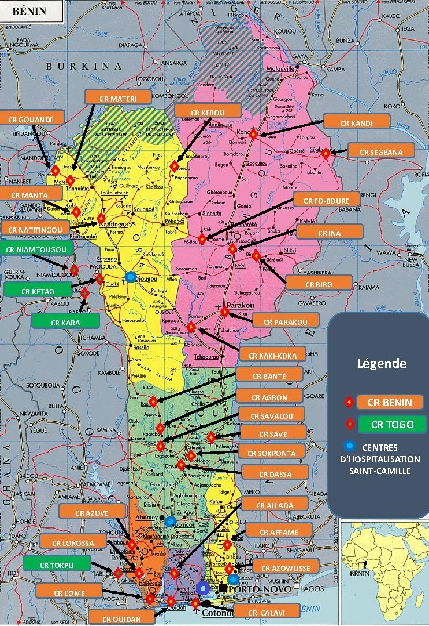
Map of Saint Camille's services in Benin

