Inviting all graduates of Mercy In Action College of Midwifery, and all Alumni of any of our educational offerings over the years and anywhere in the world! Come join us!
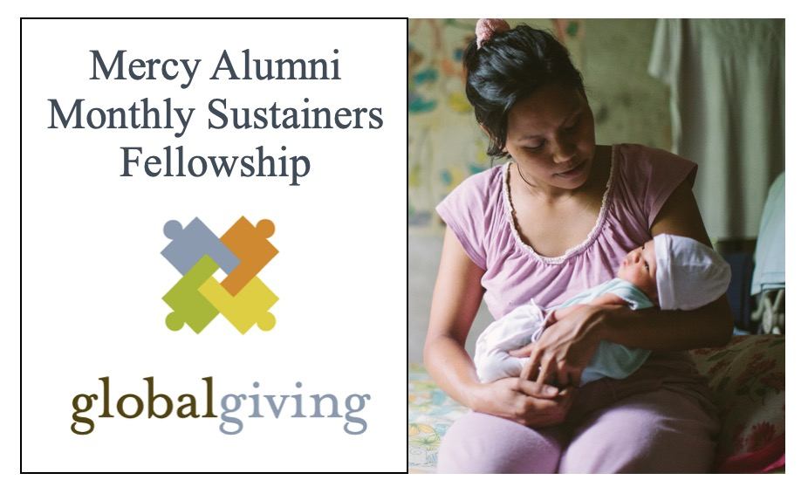
This is your invitation to join MERCY ALUMNI MONTHLY SUSTAINERS FELLOWSHIP!

We are so excited to invite you into our newly created Mercy Alumni Monthly Sustainers Fellowship! By joining, you will be pledging a monthly support to Mercy In Action’s birth centers in the Philippines. In return, you will belong to a fellowship group that will get regular reports, updates, and birth stories, as we share how our midwife-led outreach birth centers, owned by local Filipina midwives and supported by Mercy In Action, are achieving great outcomes in some of the poorest medically under-served areas of the Philippines.

You can join anytime, with any amount that works for you. Recurring donations between $10 to $200 a month will be matched by GlobalGiving when you join during the December 2021 Monthly Donor Drive.

Consider this your invitation to join and belong to the deeper Mercy In Action story!

Love and Welcome,

Vicki Penwell

