...
Gawad Pangarap Foundation, Inc
8875 Hillery Drive, San Diego, CA 92126

Greetings,

Gawad Pangarap Foundation, Inc. is a fully registered, non-profit organization based in San Diego, CA, USA. The Foundation aims to sponsor highly intellectual, indigent elementary graduates go thru 6 yrs in High School. The chosen school for these kids is Tagudin National High School in Tagudin, Ilocos Sur, Philippines.
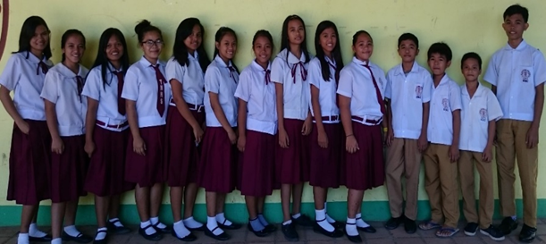
Pls. help us support these kids in the realization of their dreams! We have financial needs for: school supplies, foot wears, school uniforms and of course, tuition fees. Whatever amount you can give will be greatly appreciated. Your donation is tax deductible. 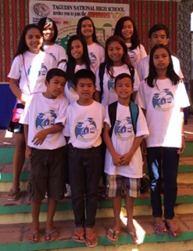
The number of Scholars we admit to the Scholarship Program depends on how much the Foundation is able to solicit for the year. Currently, we have a total of 15 Gawad Pangarap Scholars. The Foundation could not have done this without your financial support. We truly appreciate you!!
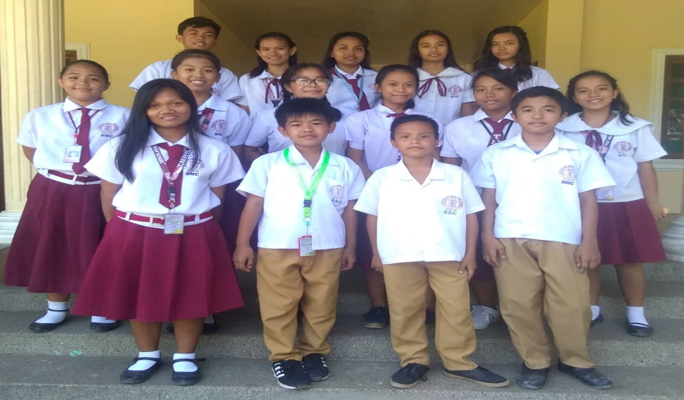
Pls send your tax- deductible donations to: Gawad Pangarap Foundation, Inc
8875 Hillery Drive, San Diego, CA 92126
Thank you very much and God Bless!
Respectfully,
Gawad Pangarap Foundation Directors,
Nuevo Lozano
Richard Valbuena
Janette Monillas
Mario Lozano
Grace Apusen

