Hurricane Matthew in Haiti: The Challenge

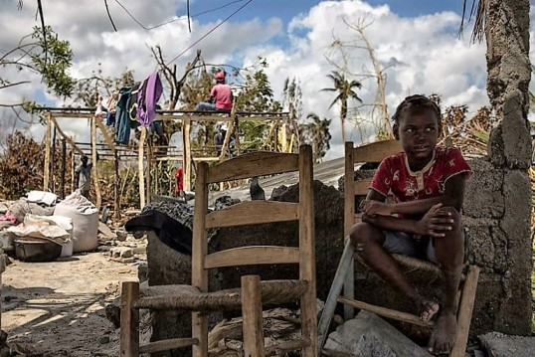
On October 4, 2016, Hurricane Matthew, a violent category 4 storm lashed into south-western Haiti. With sustained winds of 235 km/hour (145 mph), homes, livelihoods, roads and critical infrastructure were destroyed, with massive population displacement. As of 13 October, with humanitarian assessments ongoing, the Haitian Directorate of Civil Protection confirmed 473 deaths, 339 injuries, and 75 people missing; with 61,537 evacuees in 6 departments. With a ‘crisis within the crisis’ of cholera looming, the death toll and scale of loss will surely rise in the days ahead.
Initial damage assessments report that a total of 2.1 million people have been affected by Hurricane Matthew – with 12.9% of Haiti’s population (or 1,410,907 people) in need of humanitarian assistance. Of those, 592,581 are children (UNICEF estimates).
The hurricane exacerbated the vulnerability of much of Haiti’s population – over sixty percent of whom live in poverty. In its appeal launched on 10 October, UN OCHA describes: ‘little resilience to withstand and recover from crises, while at the institutional level, the capacity to respond to humanitarian risks - without external support - remains also limited.’ Fuel shortages are reported, impeding the life-saving work of humanitarian actors and compounding challenges for individuals and families to survive and withstand the current crisis.
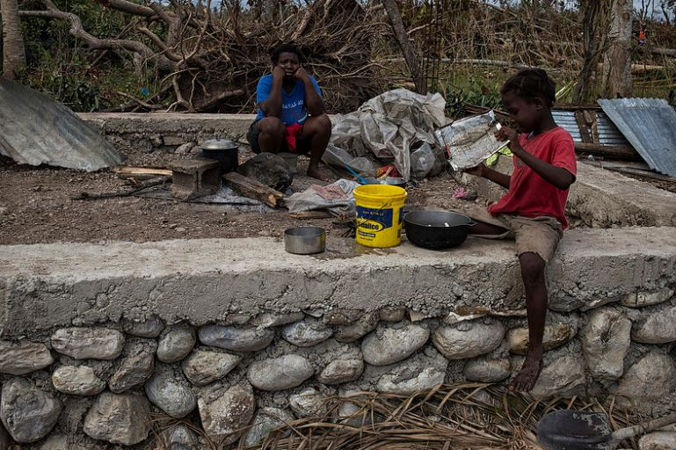
The most affected departments are Grand'Anse, South, Nippes and South East, with some communities still completely cut off from aid due to collapse of infrastructure, roads and communication networks. With the extent of damages yet unclear, livelihood sources including most of the crops were destroyed and fishing equipment washed away. In addition, many sources of natural water have been contaminated and the World Health Organization reported an increase in cholera cases. With the double threat of cholera and famine looming ahead, it is crucial that fuel be made immediately available to be used by local communities and first responders for their response and recovery.

The Response
Fuel Relief Fund’s experienced volunteer First Response Team will source and provide fuel to affected communities, institutions and aid agencies, powering orphanages, medical clinics, vehicles and generators; and facilitating access of tens of thousands of people to medical aid, shelter, food, water and light. Additionally, Fuel Relief Fund will partner with national corporation Petrogaz Haiti SA, and other worthy community and national structures to deliver fuel rapidly into the hands of those who need it most. Fuel and power supply is critical to the survival of victims and ensuring a timely, effective and efficient disaster response. Fuel Relief Fund will prioritize responding to fuel shortages in heavily-damaged coastal community of Jérémie and others in the affected areas. Fuel will also allow cooking and boiling water to prevent the spread of cholera and other water-borne diseases. As always, Fuel Relief Fund will provide fuel appropriate to local needs, including but not limited to Gasoil (Diesel fuel), HFO (Mazut) and Gasoline (Mogas 95).
The United Nations Office for the Coordination of Humanitarian Affairs (UN OCHA) has launched a humanitarian appeal seeking US$119.8 million in emergency funding to meet the most urgent needs of 750,000 people affected by Hurricane Matthew. Many of them live in rural areas that are harder to reach, which poses logistical constraints to relief efforts. Fuel Relief Fund will support efforts of our partners to reach people in outlying areas. Fewer humanitarian agencies are operating on the ground in Haiti than were there after the 2010 earthquake, and with scarce resources help is slow to arrive to many communities. Fuel Relief Fund works closely with our partners UN OCHA and the World Food Programme and partners in the logistics cluster system to coordinate all aspects of our response.

Fuel Relief Fund’s Relief Efforts
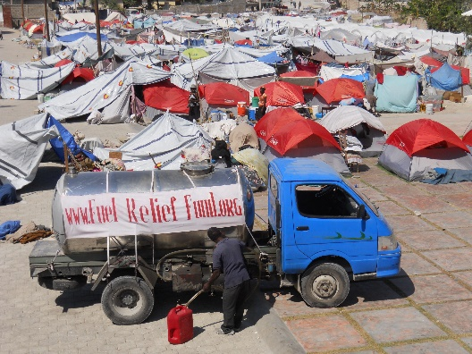
In 2010 a devastating earthquake stuck Haiti, leaving the entire country without power. Fuel Relief Fund was among those first to respond, providing fuel and bringing light to tens of thousands of displaced families and individuals housed in dark tent shelters; and powering up generators for police stations, hospitals, medical clinics, and orphanages. Fuel Relief Fund has provided fuel relief to people affected by major disasters over the past nine years, including the Ecuador earthquake, Nepal earthquake, typhoon Haiyan, the earthquake and tsunami in Japan, hurricanes Rita and Sandy, and more. In addition to providing for direct needs of communities affected by the earthquake, the fuel we supply to local, state emergency, United Nations and international relief agencies enables aid to more quickly reach larger numbers of people in need. Fuel Relief Fund is known as an efficient, reliable and nimble partner, able to rapidly deliver direct relief into the hands of people affected by major disasters. In Ecuador, the fuel we distributed allowed 50,000 people to cook and boil water for one month after the earthquake.

About Fuel Relief Fund

Fuel Relief Fund is an international nonprofit organization based in the United States and the Netherlands, with a ten-year track record of deploying and successfully solving the emergency fuel needs in major disasters across the globe. Together with our Board of leading industry experts, Fuel Relief Fund has over 100 years of combined experience in fuel supply chain, distribution, security, and emergency response. An independent operational support partner of UN OCHA, our volunteer First Response Teams team up with local and national communities to source and provide fuel for individuals and families affected by disasters, as well as powering the work of relief agencies and first responders, ensuring better access to medical care, food and shelter. For more information about Fuel Relief Fund's mission and activities, visit http://fuelrelieffund.org/

Please contact:
Melisa Lindros, Executive Director Fuel Relief Fund
mlindros@fuelrelieffund.org +1.951.322.1481
http://fuelrelieffund.org/fuel-for-haiti

