
Project Title: Reach Out’s Innovation Challenge: tapping the unknown potential of underpriviliged communities in the South-West Region of Cameroon
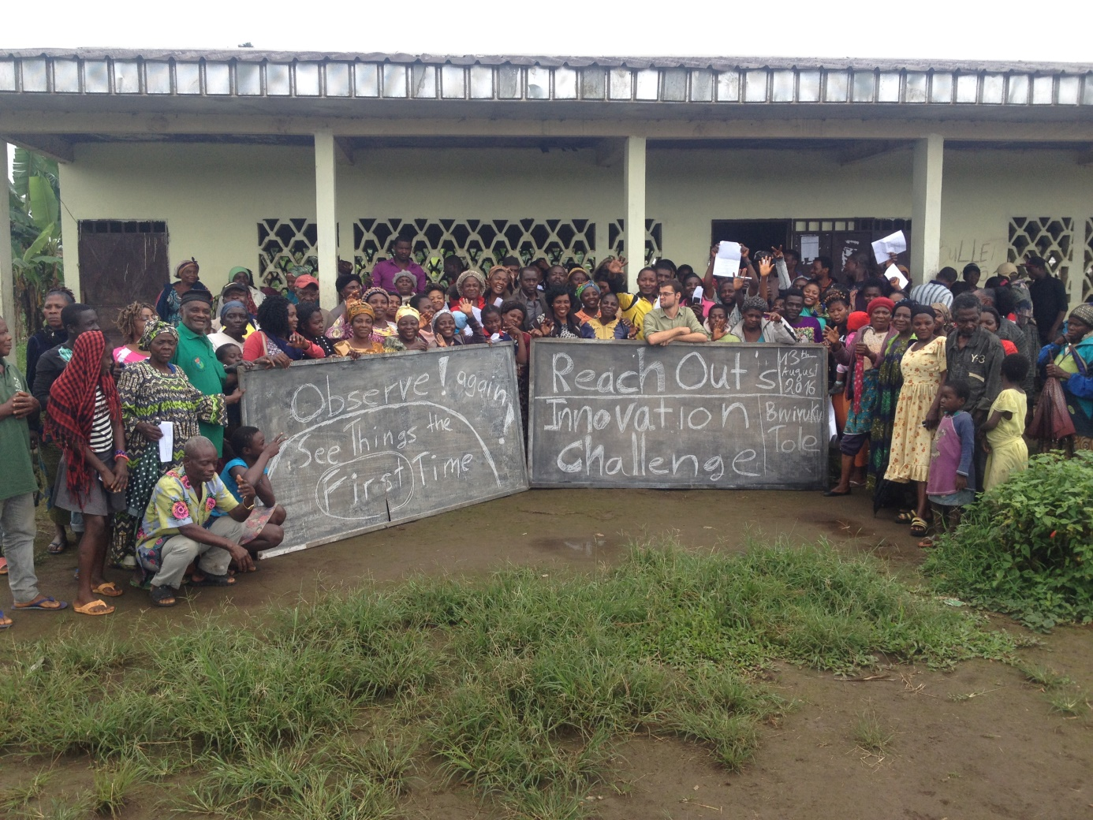

P.O. 88 BUEA
SOUTH-WEST REGION
CAMEROON

Email: info@reachoutcameroon.com / esther@reachoutcameroon.com

TEL:(+237) 233 32 35 06, 677 40 56 02
REO on Social media:


Reach Out’s Innovation Challenge: tapping the unknown potential of underpriviliged communities in the South-West Region of Cameroon
BACKGROUND

The economic environment in the South-West Region of Cameroon is narrow, community members have very limited business options and often copy each other. In this climate of perfect competition, where every neighbor sells the same than the next one, farmers and business owners opt for reducing prices or accepting very slow turnovers, profits keep reducing and with them monthly incomes. Lack of innovation is a problem, a very tangible problem with clear economic impact, yet one that is hardly addressed.
Cameroonians go through a classical post-colonial educative process that prioritizes obedience, repetition and order in front of critical thinking, innovation and chaos, wiping out creative thinking from the pupils. Because of this, and the narrow visible economic landscape, it is often said that Cameroonians don’t have creative thinking capacity. This project is a challenge to that.
Snail farming, aquaculture, transformation of agricultural outputs (juices, jams, flours..), cooperative conservation facilities for farmers, libraries and playgrounds for the underprivileged, community security firms, producing wine out of rare tropical fruits, production of Bio Gas from kitchen and farming waste, comedy centers.
The enumerated concepts above are the product of Reach Out’s Innovation Challenge - Tole, 2016. They were developed and presented as business ideas in the core of Tole, Buea, South-West Region, Cameroon, an underserved community with rampant unemployment and high HIV and illiteracy rates. These are not Reach Out Cameroon ideas. These are the ideas of young unemployed men, of illiterate farmers of old age, of young girls that had to drop out of school due to pregnancy, of people living under extreme poverty.
They were developed in less than 3 weeks, after two short workshops of not up to 3 hours. Innovation can be learned, at any age and fairly quickly. As extensive research proves.
Not only innovation can be learned, it’s an exponential process. The more you practice it the better you get at it.
Tole 2016 was a pilot project, the overwhelming results bring us to scale up the contest and extend to 3 more communities. We can’t venture to say what can happen If the Innovation Challenge happens every year during 5 years, during 20. But we know next year will be better, and we aim, on the long run, to radically transform the communities to serve as hubs of innovation in the South-West Region.

JUSTIFICATION

Reach Out´s Innovation Challenge uses three basic tools to change the minds and the landscape of Communities of the South-West Region:

- An open contest with a token monetary prize for the 3 most innovative business ideas. To put in place incentives for creative thinking.
- Periodic short workshops on Creative Thinking. So community members appropriate and use creative thinking techniques. (To facilitate the learning and appropriation process, short workshops spaced in time are preferred to concentrated trainings)
- Coaching and follow-up with feasible ideas presented to facilitate access to credit (through a partnership with Tole Tea Cooperative Credit Union) and source international donations and grants. To ensure transformative value creating ventures are put in place by the individuals and the communities themselves.

The use of challenges today has become state of the art by government agencies and international corporations and foundations. It’s a solution tailored to finding the most resourceful individuals with a limited budget. This project brings this tool to the local level, acknowledging that Fako Division and Cameroon are rich in potential changemakers waiting to be discovered.

GOAL
This project aims to build the creative capacity of community members of 4 communities of Fako Division, Cameroon within 6 months.

SPECIFIC OBJECTIVES
- Coach at least 600 participants, receive at least 300 applications and give 12 prizes to community members in Tole, Mile16, Wotutu and Bojongo of Fako Division.
- Facilitate access to capital to at least 40 entrepreneurs with creative and feasible business projects
LONG TERM GOAL
Radically transform target communities to serve as hubs of innovation in the South-West Region and Cameroon.
TARGET
The main targets of this program are men and women over 16 years of age living in the communities of Tole, Mile16, Wotutu and Bojongo.
These are all underserved communities of similar but not identical background.

TIME FRAME:
This project is expected to last for a period of one year, after which the project will be evaluated and recommendations and action plan for second year developed. Each quarter of the year covers a community, with 1 month of open contest and training and 2 months of 1on1 business development.

METHODOLOGY

For each community:

- Mobilisation and Sensitisation
Key stakeholders in every community and at regional level (community groups, traditional authorities, government agencies) will be reached to through information letters and phone calls and other traditional tools such as Town Criers.

- Coaching
3 open workshops will be held in every Community, about creativity and innovative thinking related to business. These will serve also to clarify the purpose of the challenge, identify potentials and enhance them.

Topics of training:
    - General Creativity, creativity games
    - Development of Innovation (Invention, Copy, Expansion)
    - Innovative Thinking (Association, Question, Observation, Experimentation, Networking)
    - Invention through the value chain
    - Practical innovation
    - Permanent strategies to continue thinking differently

- Reception of ideas
For 3 weeks there will be an open competition where participants will be able to submit their ideas with Reach Out and at Tole Tea Cooperative Credit Union Facilities, at the end the best 3 innovative business ideas are going to win monetary prizes

- Prize Ceremony
Awards will be given to the best ideas in short ceremonies in community spaces, this will also serve to celebrate the entrepreneurial capacity of inhabitants and extract conclusions about how to apply innovative thinking to the community.

- Implementation
All interested participants that had business ideas deemed solid by Reach Out and are members of Credit Union (the most widely used financial institution used in this areas) will opt to a loan. Additionally Reach Out will look for other sources of funding among international donors (Foundations supporting entrepreneurs) and nationally (opportunities from government agencies for particular businesses, normally related to agriculture, but not exclusively). Besides this each winner will be featured in the platform GlobalGiving.org for 3 months to obtain seed capital for their venture.

OUTPUT

- At least 600 participants per year receive and assimilate lessons on creativity and innovation, put them in practice in their private lives and share them with their peers
- At least 300 participants design and present business ideas.
- 12 prices will be given for the most innovative ideas
- 4 ideas will be awarded with a micro project about them on Global Giving.
- 40 ideas will be developed and supported with loans through the micro financial institution partner to the project (Tole Tea Cooperative Credit Union) and other funding opportunities.

OUTCOMES

This project is expected to improve on the livelihoods of at least 600 participants by:
- Improving Innovative Thinking
- Diversifying the economic landscape
- Implementing feasible business proposals together with microfinance institutions
- Creating new sources of income
The communities as a whole will also benefit from the program as subsidiary beneficiaries.

M&E

In order to evaluate the success of the project the following tools will be used:
- Assessment of participants knowledge, attitudes and behaviours related to creativity (pre- and –post training)
- Assessment of participants knowledge, attitudes and behaviours related to entrepreneurship (pre- and –post training)
- Feedback from participants and community stakeholders gathered in periodic Review Meetings.

Indicators of success are: Workshop turnover, Number of ideas presented, Number of ideas financed, Knowledge and Satisfaction of participants
These will be analysed using attendance sheets, application forms, satisfaction surveys and reports and gathered in a final report to be distributed among relevant stakeholders.

SUSTAINABILITY
The economic empowerment and Capacity Building of the participants will have impact throughout their whole lives, with spill-over effects in the community as a whole. Innovation is a powerful force that affects everything around it, by repeating the contest yearly prospective participants are motivated to keep thinking of new business ideas, and many of them might realize they don’t need to wait for the contest to implement them. Innovation does not limit itself to business, innovative citizens raise more innovative children, look different at community problems, the impact will be felt in all ambits.
By focusing on financing tangible businesses we make sure the impact of the project is felt after its implementation, the successfully supported businesses will provide not only sources of income to fight poverty and diversification of the economic landscape, making the community more solid economically, they will also be ambassadors of creativity, physical examples of innovation to be seen, copied and learned from by other community members.

BUDGET

To carry out this project for one year, a total sum of 792,000 francs CFA will be required.

Summary Budget:

Reach Out Innovation Challenge 2017
Description | Total CFA | Total €
Mobilisation and Sensitization | 44000 | 67
Trainings on Creativity | 264000 | 403
Challenge Awards | 240000 | 366
Technical assistance for implementation of ideas | 30000 | 46
Administrative costs and overhead | 210000 | 321
TOTAL | 788000 | 1203

The Innovator’s DNA, Harvard Business Review (Jeff Dyer, Hal Gregersen, Clayton M.Christensen)

