Snehalaya’s response to the second wave of COVID

Snehalaya is an Ahmednagar District-based NGO working for the rehabilitation of people living with HIV / AIDS and women and children for over three decades. This includes, but is not limited to: sex workers and their children, transgender and MSM communities, rape victims including minors and unwed mothers, newborns and infants, victims of domestic violence, slum communities, child laborers, child brides and other exploited and deprived sections of society. While helping our beneficiaries through 22 tailored projects, we also respond to calamities like floods, droughts, earthquakes and epidemics/pandemics, and are currently focused on the COVID pandemic, providing emergency support and services across our district.
The second wave of COVID is devastating India. Ahmednagar District, where Snehalaya operates is one of the worst hit with no beds, oxygen or medicines available to our largely rural population of nearly 5 million which already experiences high unemployment and a severe lack of statutory healthcare. Drought, poverty and a large transient population has historically perpetuated many issues for low-income families, most of whom earn their living from agriculture, daily wage or migrant work.

Since March 2021 a flood of positive cases has rendered the current medical facilities throughout the district overburdened and insufficient. There has been a steep rise in the number of Corona positive patients in the district and at the start of April, Times of India reported it was in the top ten worst affected districts in India with over 1,000 new cases a day. The Hindustan Times further reported that: “From April 15-21, when Maharashtra recorded its highest seven-day average in both cases as well as fatalities, the case fatality ratio (CFR) of five districts posed the most concern. Of them, Ahmednagar recorded the highest at 1.4%, followed by Nagpur (0.95%), Mumbai (0.64%), Nashik (0.62%), and Pune (0.33%).”

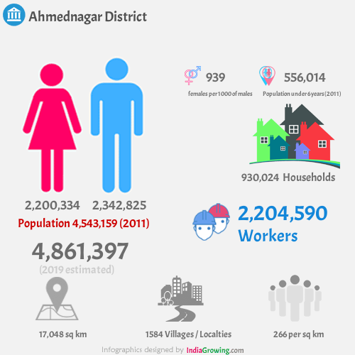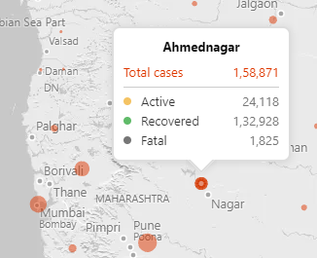

The present quarantine and medical facilities in the city are full and overburdened. With no beds and limited oxygen and medicines available in government or private hospitals, admission and treatment for patients has become extremely challenging and next to impossible with profiteers exploiting people through the black market.

To relieve the burden on medical facilities, those testing positive with minor or no symptoms are advised to self-quarantine. However, for those on low or no incomes who live in very small houses or slum dwellings isolation of COVID positive family members is simply not realistic. For those with more serious symptoms the lack of resources and inflated fees involved in gaining what treatment is available is beyond their reach.

At the same time cases of trafficking, child marriage and domestic violence are also increasing and, with many businesses and government offices closed or reduced, there is very limited access to support services. Police blockades and limited public transport are also making it difficult for those seeking medical attention and other support.

Our Solutions

In response to the critical situation we have put pressure on authorities, such as the Chief Minister of Maharashtra, our District Collector and others to take direct action to improve the situation. We have also issued regular media statements requesting them to ensure proper access to hospitals and supplies of oxygen and medicines such as Remdesivir to COVID positive patients, particularly for those from lower socio-economic backgrounds. As a result, our District Collector has initiated a 24/7 helpline to control the chaos and scramble for treatments the pandemic is causing and we are encouraging further action.

We are also taking a more direct approach, adapting, expanding and initiating new projects to provide vital support to as many of the 150,000 plus people who have tested positive with COVID in our district. Outreach work, ambulance services and our community radio are helping us to reach out to communities in all corners of our district.

Health support

We believe that early identification of patients and confirmation of their symptoms and putting them in isolation and on immediate medication is key to avoiding complications and beating the virus. We are prioritizing the most marginalised sections of society in urgent need of treatment and admission primarily residing in Ahmednagar District.

Covid Care Centers

We have given our hospital over to COVID patients with around 70 patients a day receiving treatment. We have also opened a 130-bed COVID Care Center with 8 days of residential medical and quarantine facilities for asymptomatic patients and those with mild to moderate symptoms, all free of charge.

Anamprem Covid Care Center, Nimblak, Ahmednagar
Contact: 9011020174.

Snehadeep

Snehdeep Care Home is working as an alternative between hospital and home for cancer, dementia, coronary anemia, injuries, post-operative care and any sudden disability for patients unable to get medical help at home. Available at reasonable fees and initiated by an alumnus of Snehalaya.

Contact: 9422735736

Detox & Rehabilitation Center

Treatment for addictions to: Alcohol - Cannabis - Opium - Cigarettes - BD Gutkha - Brown Sugar - Mava - Tobacco – Corex, etc. Initial treatment is for 30 days in full-time residential care at a reasonable cost.

Sneha-Shraddha, Nimblak, Ahmednagar
Contact: 7499980845, 9834319601

Sneha-Shraddha - Manasgram

Counseling, treatment and rehabilitation to mentally ill, homeless from the streets and their families, including free psychiatric medication for two years after returning home.

Sneha-Shraddha, Nimblak, Ahmednagar
Contact: 9011011006

Snehankur

Immediate, free service for orphaned and unwanted babies, unmarried mothers, rape victims or any other mother unable to safely access maternity care.

Snehankur Center, Kedgoan, Ahmednagar
Contact: 9011026483, 7770027505

Other support

Our established 22 projects continue to operate and our 24/7 helplines offer support to all women and children to counteract the issues created by the shadow pandemic including a significant rise in domestic violence and child marriage cases and anticipated child trafficking cases.

By supporting the most vulnerable groups with medical support during the current second wave we will improve their chances of surviving the pandemic crisis and reduce the number of people requiring our help once the crisis ends. We will also provide women and children with the help and services they need in order to rebuild their lives long after this pandemic has been contained. This includes women and children at risk from trafficking and women in our communities who are suffering from domestic violence, now and post lock down.

Childline

If you are worried about the welfare of any child please contact the team through our 24/7 Helpline, 1098.

Sneha-Paris

A residential rehabilitation project, implemented by our Childline under the guidance of the Child Welfare Committee in compliance with all the provisions of the Juvenile Justice Act, for children who have lost a parent due to COVID. This offers a safe space for children to prevent the trafficking and exploitation of orphans. It is also available for children whose family members have tested positive and are unable to isolate at home, providing 15 day’s residential care and protection.

Kedgaon, Ahmednagar
Contact: 9011026495, 9011011005, 9011026483 and 9011026493

Child marriage
According to a 2019 UNICEF report, out of the 739 districts in India, Ahmednagar District rated as the 15th highest for child marriages. Childline India has also reported that Ahmednagar has the highest number of child marriages out of the 36 districts in Maharashtra. The incidences of child marriage have increased dramatically during the pandemic. During the 2020 lockdown our Childline team remained vigilant, preventing 88 child marriages in Ahmednagar District, offering follow-up support to the children rescued. We continue to respond to child marriages. Please contact the team on 1098 24/7 to report and prevent a child marriage.

Contact: 1098

Womens’ Helpline

Telephone counselling offers legal advice and support, our short-stay home gives women medical care, shelter, counselling and guidance to deal with the immediate issues and we also provide long-stay alternatives for those unable to return home.

Contact: 9011363600

Give India Financial Aid
Snehalaya Parivar is working with Give India to provide financial assistance to the families whose main wage earners have died due to corona. If you are anyone you know has been affected, please get in touch.

Contact: 9011026485

