

Food Program Report

We are grateful for your investment in and friendship with Rosie’s Place. Because of your partnership we are turning hope into help for thousands of poor and homeless women each year.
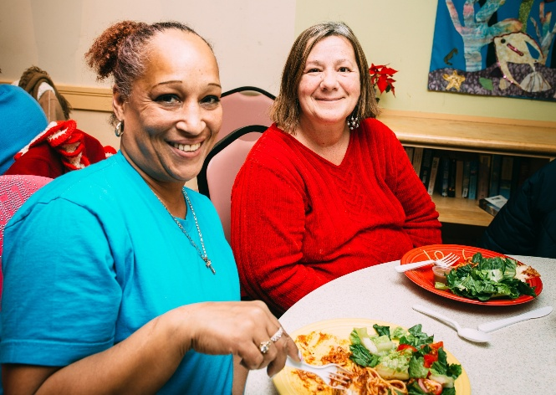
Many guests are first introduced to Rosie’s Place through the Food Program.
The poor and homeless women we serve every day deserve to live long, healthy, stable, and productive lives. Because of the Food Program at Rosie’s Place, more women are healthier: more women and their families are eating healthy food, and fewer women are going without meals and nourishment. With their basic needs met, more women can engage in self-care and maintain their dignity.

Addressing Food Insecurity & Reducing Isolation

Our Dining Room is the heart of Rosie’s Place and welcomes any woman and her children in need of a healthy hearty meal 365 days of the year for breakfast, lunch, and dinner:

- In the last six months we’ve served over 110,000 hearty, nutritious meals in our Dining Room. We are anticipating serving at least 190,000 meals total and are on track to meet or exceed that goal. In Q1 (July – September 2025) we served 29% more meals than this same period last year and in Q2 (October– December 2025) we served 16% more meals than last year.

Last fiscal year (July 2024-July 2025), Rosie’s Place served 187,000 meals, a 23% increase from the previous year and an average of 500+ meals a day.

- We launched our winter menu, which centers warm, filling meals designed with the colder season in mind. Continually changing our menu is imperative to not only reflect our guests’ needs and preferences, but also to ensure that our guests are accessing nutritious (in-season) fruits and vegetables.

- We are now more sustainable than ever: in addition to sourcing from local farms and using eco-friendly containers for our to-go options, we have also trained all Dining Room staff in our new composting procedures now we compost approximately 128 gallons of food waste each week.

Volunteers are critical to the work we do in the Dining Room. Last year, 2,473 volunteers gave 14,547 hours of time, preparing, cooking and serving meals, and cleaning and helping us compost.


In the Food Pantry, we are providing a variety of nutritionally balanced groceries for up to 350 women daily. Guests are welcome to visit the Pantry weekly—with women over 62 welcome to come twice a week—and we are open Monday through Friday from 9:00 a.m. until we are out of food or have served 350 women.
Last year, the Food Pantry served 8,800 unique women, providing fresh produce, proteins, pantry staples, and household goods.

- In the last six months, we have already accommodated 39,958 visits to the Food Pantry, tracking ahead of the previous year. Each woman receives two bags of groceries when they visit, which means we have packed and distributed 79,916 bags of fresh groceries.

Last fiscal year, our Food Pantry provided groceries to 8,890 women, a 7% increase over the year prior. We served an average of more than 323 women a day, accommodating 78,256 visits in FY25, a 6% increase from FY24.

- We carefully monitored weather conditions for those waiting in line at the Food Pantry—guests will often start lining up before we open—and so we offer water during warm weather and hats and gloves during the winter.

- Guests received and completed a new Food Pantry Survey. The feedback is being compiled and will be used to improve services and offerings in the next six months.

A recent study by the Greater Boston Food Bank showed that 40% of food insecure households forgo necessary medical care to save money. Food-insecure households were also more likely to be socially isolated. A healthy meal or fresh groceries from Rosie’s Place—in a caring community—can help our guests feel less alone. Our Food Program prevents hunger and connects our guests to the wraparound services offered at Rosie’s Place, so that women can better manage their basic needs, access basic health care, and get support related to housing, legal issues, and more.

Impact: Monica’s Story

For years, as hard as they both worked, Monica and her husband were never able to save much. They made just enough for themselves and their young teenage daughter, Josie, to get by but could never get ahead.

So, when Monica’s husband suddenly left her, she had nothing to fall back on. Paying their rent on one income was impossible, so she took on a second job that meant she was away from home even more. They cut back wherever they could but making rent while covering utilities and the rising cost of food was a stretch every month. Then, a friend told Monica about Rosie’s Place, and she began to visit our Food Pantry early in the mornings, before her first job started. Monica cobbled together a stable life for herself and Josie, but she knew it was tenuous.

When her mother died, Monica’s father invited her and Josie to come live with him. She could help her dad around the house and cut back on her hours, allowing more time with Josie. Over the years, the three of them had their ups and downs but when Josie graduated high school and started to work full-time to save for college, Monica believed it had all been worth it.

Unfortunately, just as Monica and Josie were starting a new chapter, their foundation crumbled. Monica’s father had remarried, and his new wife didn’t want them in the apartment. With little warning, mother and daughter found themselves without a home. Once more, they went into survival mode—staying on friends’ couches, motels when they could, even sleeping in the car they shared—all while scrambling to get to work every day. Eventually, as the cold weather arrived and their options were exhausted, they couldn’t keep up the balancing act and Monica lost her job. That’s when she returned to Rosie’s Place, bringing 19-year-old Josie with her.

Monica called it a miracle when she learned that two beds were available in our Overnight Shelter. They were both so happy to regain a routine of normalcy and to have the opportunity to connect with our Housing Search and Employment Specialists.

Their three-week stay with us was lengthened over the holidays, allowing Monica and Josie time to begin new jobs as they applied for housing of their own. As Josie said, “The staff gave us support and strength when we needed it most.”

Today, mother and daughter are living together in transitional housing just down the street from Rosie’s Place, awaiting the paperwork on their new apartment to be finalized. They stop in to meet with an Advocate who is helping them with furniture for their new home. Monical and Josie visit our Dining Room for a hot meal before Monica starts her day as an administrative assistant at the hospital and Josie starts her server shift at a local restaurant.

Monica says of Rosie’s Place, “You all taught me that family isn’t just something you’re born into. Family is something that, if you’re lucky, you can build. I will forever count Rosie’s Place as my family for all you have done for me and my daughter. We are so grateful.”

Looking Ahead

As social services across Massachusetts face cuts, Rosie’s Place will remain a trusted lifeline for our most vulnerable neighbors. As part of our Strategic Plan growth, we anticipate a 25% overall increase in number of women served by FY28. Our longtime partners make our work possible and together we are creating a future where all women are met with dignity, compassion, and the support they need to thrive.

Thank you for your generosity.

