You can sponsor the following Brilliant children, the amount metioned against each child for one year or a part of it. Since there is no government school nearby,These under privileged children has to go to private schools, for which, we seek your support to provide education.
If you wish to get the updates and their status of education, Kindly send us your mail quoting the your beneficiary serial no. and name of the student, so that, we will mark as funded in this page and send you the status report once in three months along with photo.
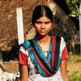47. Jenifer.14 years old, studying in 10th grade.
For 11th grade, total amount in need of Rs.8000/= or $190
Father name-(Late) Jayaraj, Mother-Rosemary
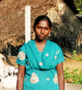48. Sagaya priya.14 years old, studying in 9th grade.
For 10th grade, total amount in need of Rs.8000/= or $190
Father name- Balasamy, Mother- Lakshmi
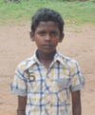40. Vasanth kumar. 13 years old, studying in 7th grade.
For 8th grade, total amount in need of Rs.7000/= or 170
Father name- Panneerselvam, Mother-KalaiSelvi
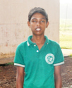41. Ganesan. 15 years old, studying in 9th grade.
For 10th grade, total amount in need of Rs.8000/= or $190
no father and mother. lives with G.mother. need food and clothing etc.
Total in need-Rs.18000/=or $ 420
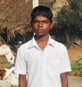42. Robin.14 years old, studying in 9th grade.
For 10th grade, total amount in need of Rs.8000/= or $190
Father name-Christ raj(Late), Mother-Indrani
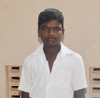43. Snathosh kumar.14 years old, studying in 8th grade.
For 9th grade, total amount in need of Rs.8000/= or $190
Father name-Francis, Mother-Chinnamma
49. Ajith kumar.17 years old, studying in 11th grade.
For 12th grade, total amount in need of Rs.9000/= or $220
Father name-( late) John Bosco, Mother-Malliga
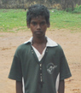32. Aravindan. 14 years old, studying in 10th grade.
For 11th grade, total amount in need of Rs.9000/= or 220
Father name- Susai raj. Mother- Gracy mary
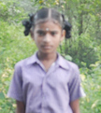55. Raymond.17 years old, studying in 11th grade.
For 12th grade, total amount in need of Rs.9000/= or $220
Father name-( late) Benjamin , Mother- Fathima
50. Raymond.17 years old, studying in 11th grade.
For 12th grade, total amount in need of Rs.9000/= or $220
Father name-( late) Benjamin , Mother- Fathima

