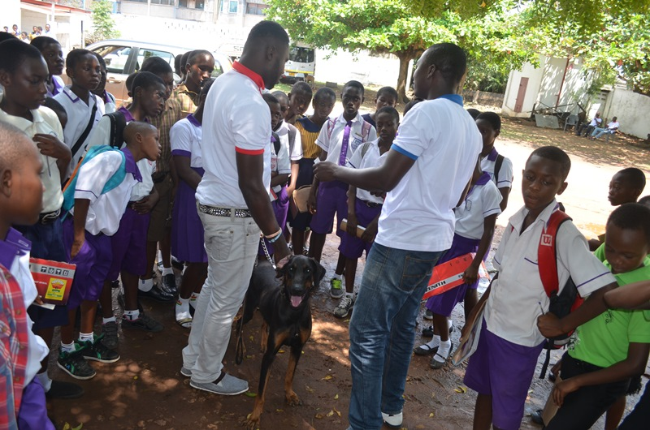  AKI provides funds for Ghana SPCA field trips for students in the Humane Ed classes.  AKI’s core values influence all we do:  - We believe that animal welfare has no boundaries.  - We believe that improving conditions for animals goes hand in hand with improving conditions for people in our AKI partner countries.  - In all we do, we show respect and understanding for the human community because working in animal welfare in AKI countries means working closely with the people who so rely on their animals.  - We believe that our partner organizations are best placed to decide on how to use AKI funds. We will not dictate; our role is to oversee the use of AKI funds to ensure they are used wisely for animal welfare purposes only.
  Donate to AKI today if you’ve felt powerless to help distressed animals in a country you’ve visited, if you’re interested in helping animals beyond your borders, and if you want to help animals where the help is needed--and can accomplish-- most.
  Contact Us
  PO Box 300
  Jemez Springs, New Mexico
  87025 USA
  575-834-0908
  karen@animal-kind.org
  www.animal-kind.org
  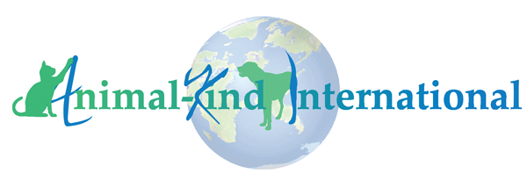
  AKI is a 501(c)(3) organization. We send 100% of all donations to our partner organizations.
  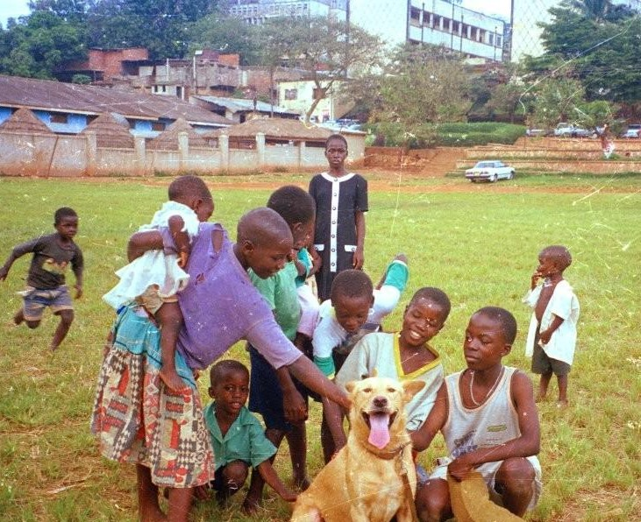
  Animal-kind internationaL
    - Kindness to Animals has no Boundaries

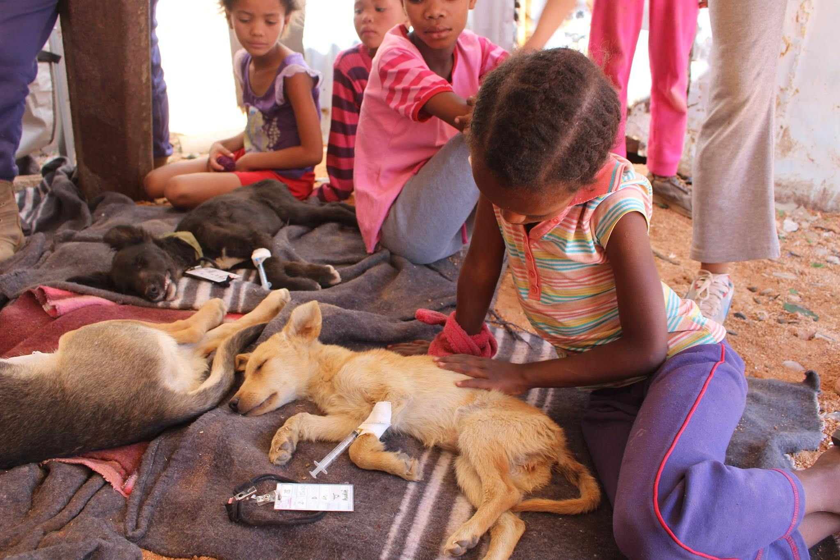  AKI provides funds for Have A Heart-Mobile’s (Namibia) community spay/neuter clinics.  Please detach this form and mail it with your donation. Distribute my donation as follows:  GSPCA_____________________  LAWCS ___________________  Namibia’s rural SPCAs & HAH_____________  South Sudan individual animal welfare  Advocates____________________  TAWESO________________________  Mbwa wa Africa___________________  Uganda SPCA____________________  SAA____________________________  HHHH__________________________  KCAW__________________________  The Hope________________________  Let AKI decide based on current needs  ______________________________ DONATION FORM |  |  | AKI supports our partner animal welfare organizations:  - Ghana Society for the Protection & Care of Animals (GSPCA)  - Liberia Animal Welfare & Conservation Society (LAWCS)  - Namibia’s rural SPCAs & Have A Heart (HAH)-Mobile  - South Sudan Humane Ed volunteers  - Tanzania Animal Welfare Society (TAWESO)  - Mbwa wa Africa (Tanzania)  - Uganda Society for the Protection & Care of Animals (USPCA)  - Save the Animals-Armenia (SAA)  - Helping Hands for Hounds of Honduras (HHHH)  - Kingston [Jamaica] Community Animal Welfare (KCAW)  - The Hope Sanctuary-Barbados  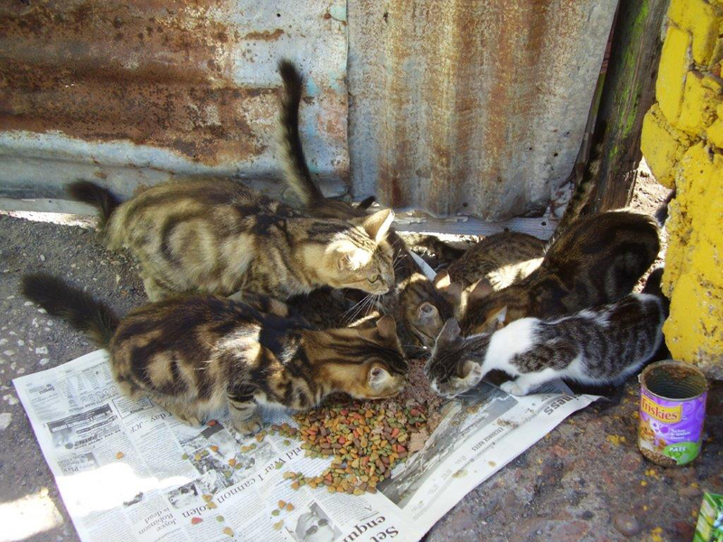  AKI provides funds for KCAW’s street cat and dog feeding program.  OUR NETWORK |  |  | 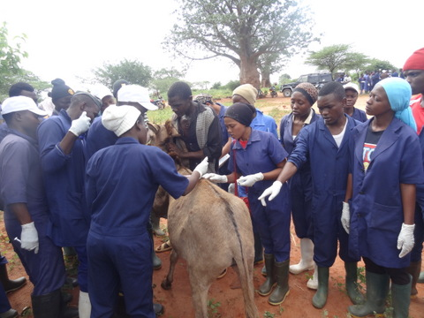  AKI supports partner organization, TAWESO’s, donkey vet care clinics in rural parts of Tanzania.  ABOUT AKI  AKI supports existing animal welfare organizations in poor countries. Because they compete with so many other causes, these organizations are unable to raise funds within their own countries to cover their needs. Yet the work they do is so critical for improving the lives of animals.  AKI raises funds for and sends supplies to our partner animal welfare organizations. We provide a secure means of delivering donations to our local partners, who so desperately need outside support.  AKI has a due diligence process that ensures donor funds are spent only for animal welfare and that allows donors to track how our partner organizations use donations.  You and AKI….building partnerships with animal welfare organizations in poor countries. Together we can improve the lives of the most vulnerable animals around the world.

